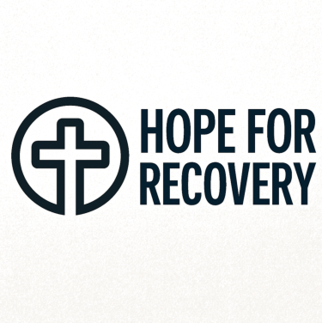

05/08/2025, 18:16 Hope for Recovery | Holistic Health Workbook

**Hope for Recovery**

**Holistic Health Workbook**

*Hope, Healing, Wholeness*

**Welcome to the 12-Week Holistic Health Course**

Over the next 12 weeks, we'll explore physical, emotional, mental, and spiritual health - their importance,

how to improve each area, and how they interconnect. Our prayer is that you'll grow into the person God

created you to be.

**Course Completion:** To earn a certificate, attend at least 6 sessions (50%) and score 50% on the final quiz.

For a merit certificate, attend 9 sessions (75%) and score 75%.

**12-Week Plan Overview**

file:///C:/Users/User1/Desktop/hope-for-recovery/workbooks/Holistic Health.html 1/20



05/08/2025, 18:16 Hope for Recovery | Holistic Health Workbook

**Week 1 Week 2 Week 3 Week 4**

|  |  |  |  |
| --- | --- | --- | --- |
| Introduction to Holistic | Spirit, Soul & Body | Physical Health | Emotional Health |
| Health |

**Week 5 Week 6 Break Week 7**

|  |  |  |
| --- | --- | --- |
| Personal Reflection | Living in the | Gratitude is the Best |
| Moment | Attitude |

**Week 8 Week 9 Week 10 Week 11**

|  |  |  |  |
| --- | --- | --- | --- |
| Mental Health | Spiritual Health | Awareness vs | Case Study |
| Awakening |

**Week 12 Certificates**

Final Assessment

**Group Rules**

1. No attendance under the influence of substances

2. No sharing or requesting illicit drugs/alcohol

3. If late, enter quietly and notify if possible

4. Respect confidentiality

file:///C:/Users/User1/Desktop/hope-for-recovery/workbooks/Holistic Health.html 2/20



05/08/2025, 18:16 Hope for Recovery | Holistic Health Workbook

5. One person speaks at a time

6. No cross-talking

7. Support, don't "fix" others

8. Limit sharing to 3-5 minutes

9. Avoid glorifying addictive behaviors

10. Maintain a positive attitude

11. Silence mobile devices

12. Refreshments during breaks only

13. Embrace truth, honesty, and respect

**Week 1: Introduction to Holistic Health**

To begin, rank the four health components by importance and rate your current status (1-10):

**Health Area Importance (Rank 1-4) Current Score (1-10)**

Physical

Mental

Spiritual

Emotional

file:///C:/Users/User1/Desktop/hope-for-recovery/workbooks/Holistic Health.html 3/20

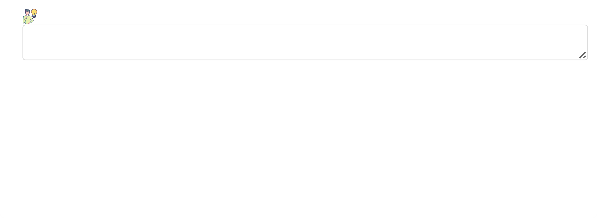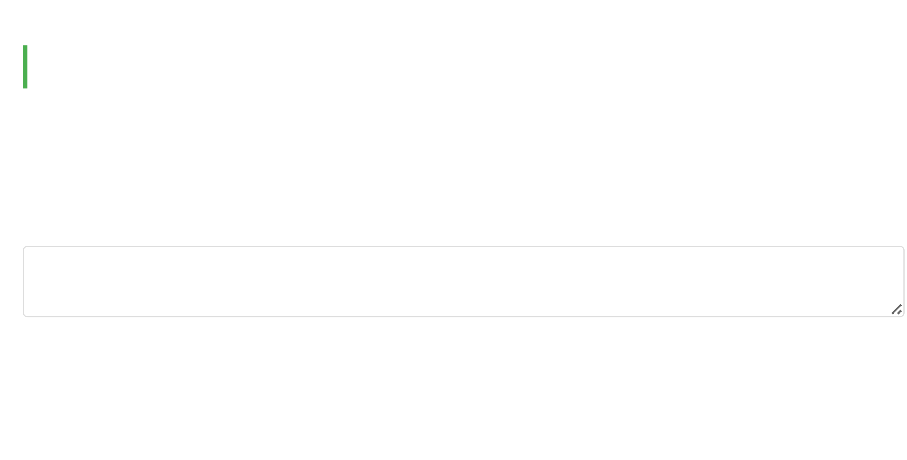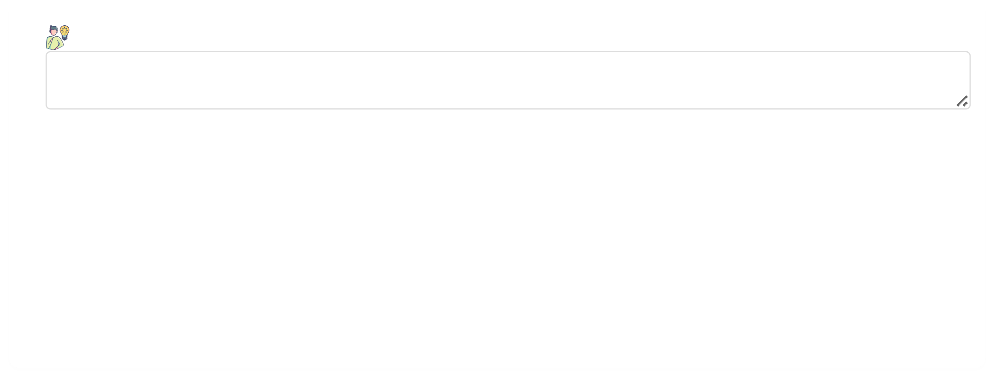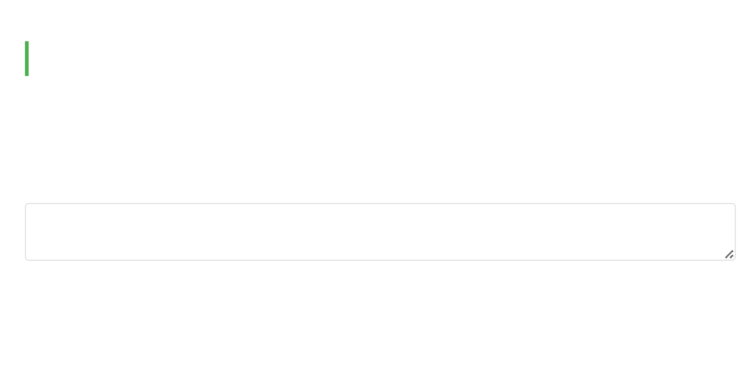

05/08/2025, 18:16 Hope for Recovery | Holistic Health Workbook

**Reflection:** Why did you choose this order? How might it change by Week 12?

Write your thoughts here...

***Memory Verse (1 Corinthians 15:45):***

*"The spiritual did not come first, but the natural, and after that the spiritual."*

*This verse reminds us that while physical health is important, spiritual growth follows as we mature.*

**Week 2: Spirit, Soul & Body**

Mankind is a triune being made up of three parts: spirit, soul, and body. Today we'll explore the purpose of

each component.

**1. What is the purpose of your spirit?**

Discuss in your group and write your thoughts here...

**2. What is the purpose of your soul?**

file:///C:/Users/User1/Desktop/hope-for-recovery/workbooks/Holistic Health.html 4/20

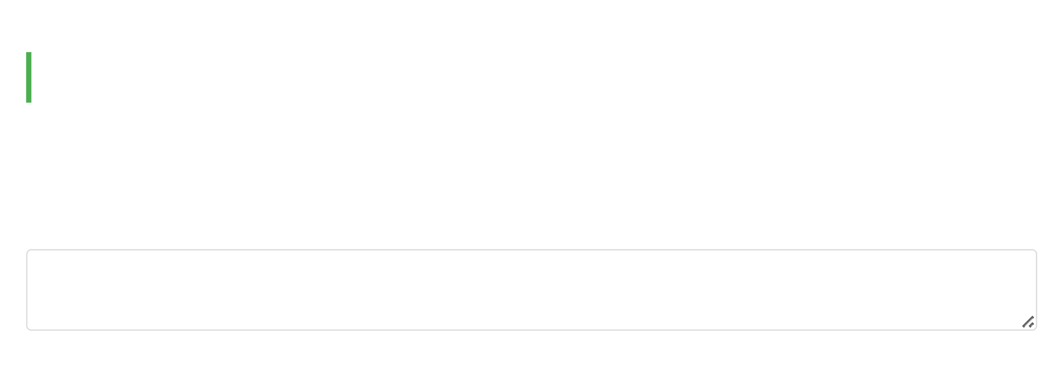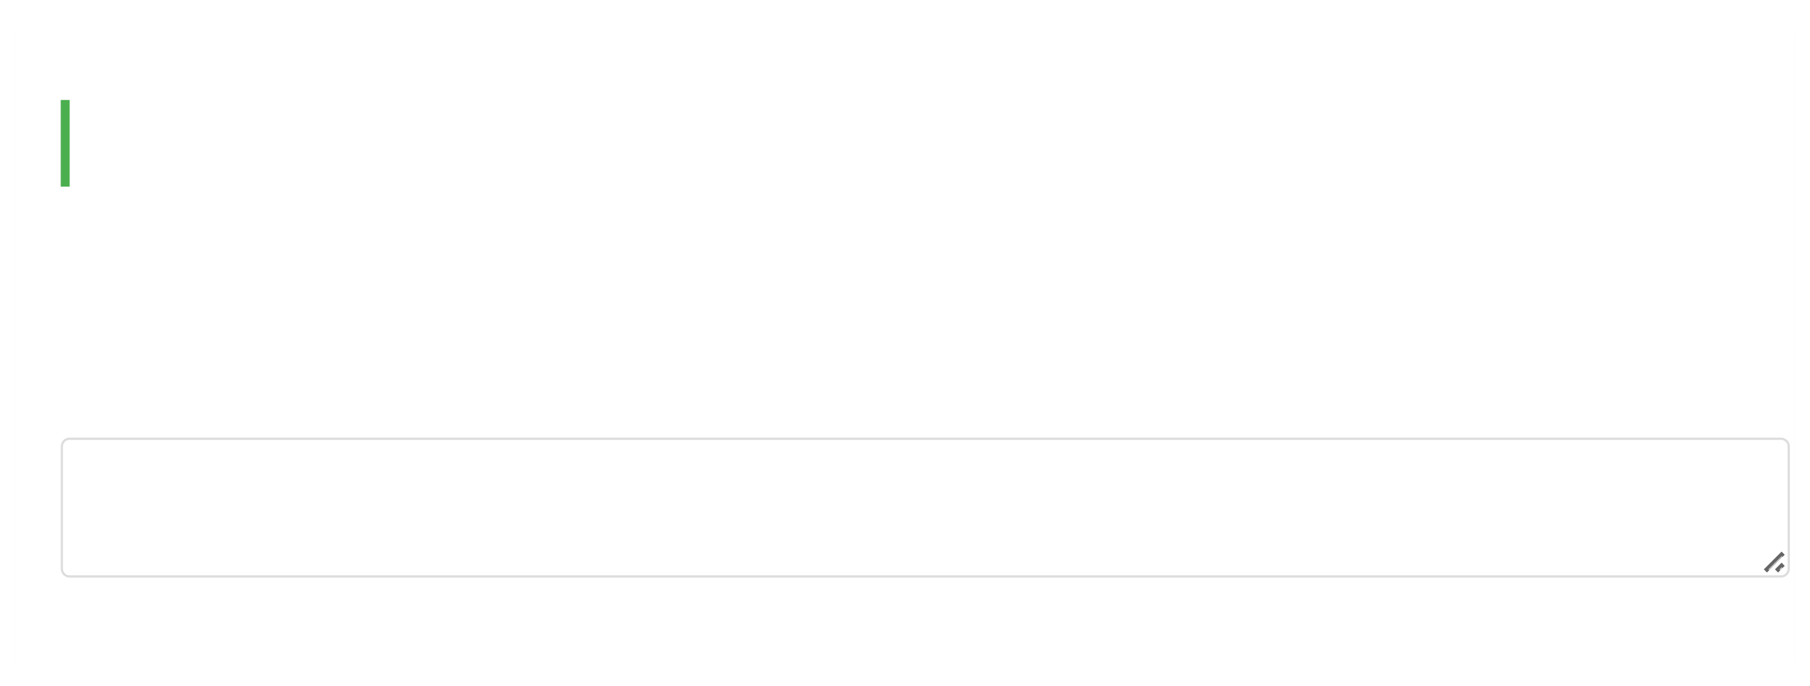

05/08/2025, 18:16 Hope for Recovery | Holistic Health Workbook

Discuss in your group and write your thoughts here...

**3. What is the purpose of your physical body?**

Discuss in your group and write your thoughts here...

***Memory Verse (1 Thessalonians 5:23b):***

*"May your whole spirit, soul and body be kept blameless at the coming of our Lord Jesus Christ."*

*This verse emphasizes the importance of caring for all parts of our being.*

**Week 3: Physical Health**

Today we'll explore physical health - what it is, its benefits, and how to improve it.

**1. How would you define physical health?**

Group discussion notes...

file:///C:/Users/User1/Desktop/hope-for-recovery/workbooks/Holistic Health.html 5/20

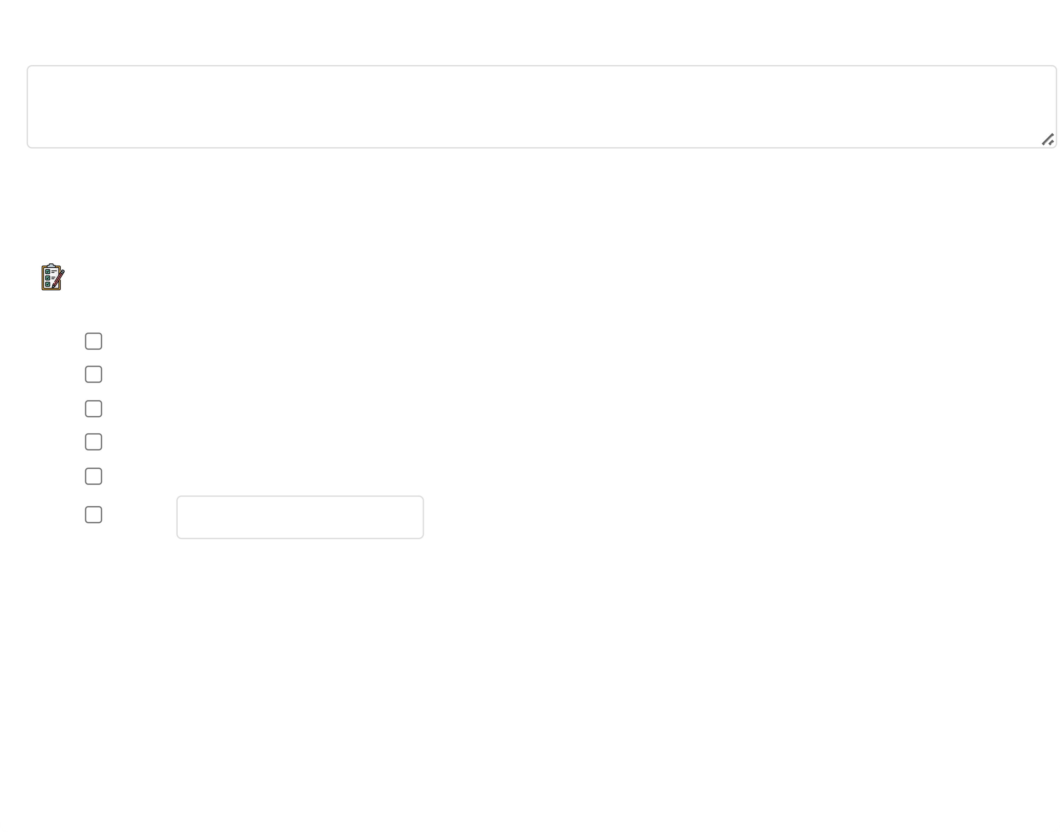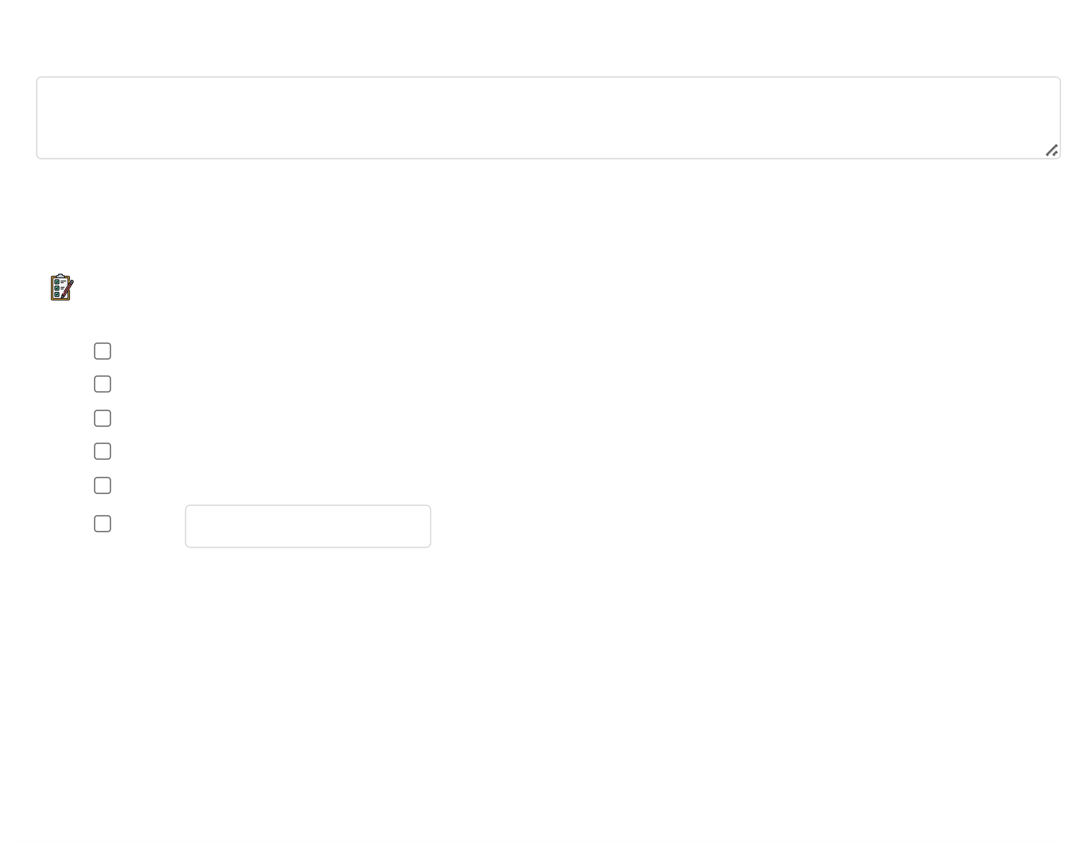

05/08/2025, 18:16 Hope for Recovery | Holistic Health Workbook

**2. What are the benefits of good physical health?**

Group discussion notes...

**3. Ways to improve physical health:**

**Action Plan:** Check goals you want to work on:

Regular exercise (3+ times/week)

Balanced nutrition (fruits/vegetables daily)

7-8 hours of sleep nightly

Annual medical check-ups

Hydration (8 glasses of water daily)

Other: Specify

***Memory Verse (3 John 1:2):***

*"Dear friend, I pray that you may enjoy good health and that all may go well with you, even as your soul*

*is getting along well."*

*This shows God's desire for our physical and spiritual well-being.*

file:///C:/Users/User1/Desktop/hope-for-recovery/workbooks/Holistic Health.html 6/20

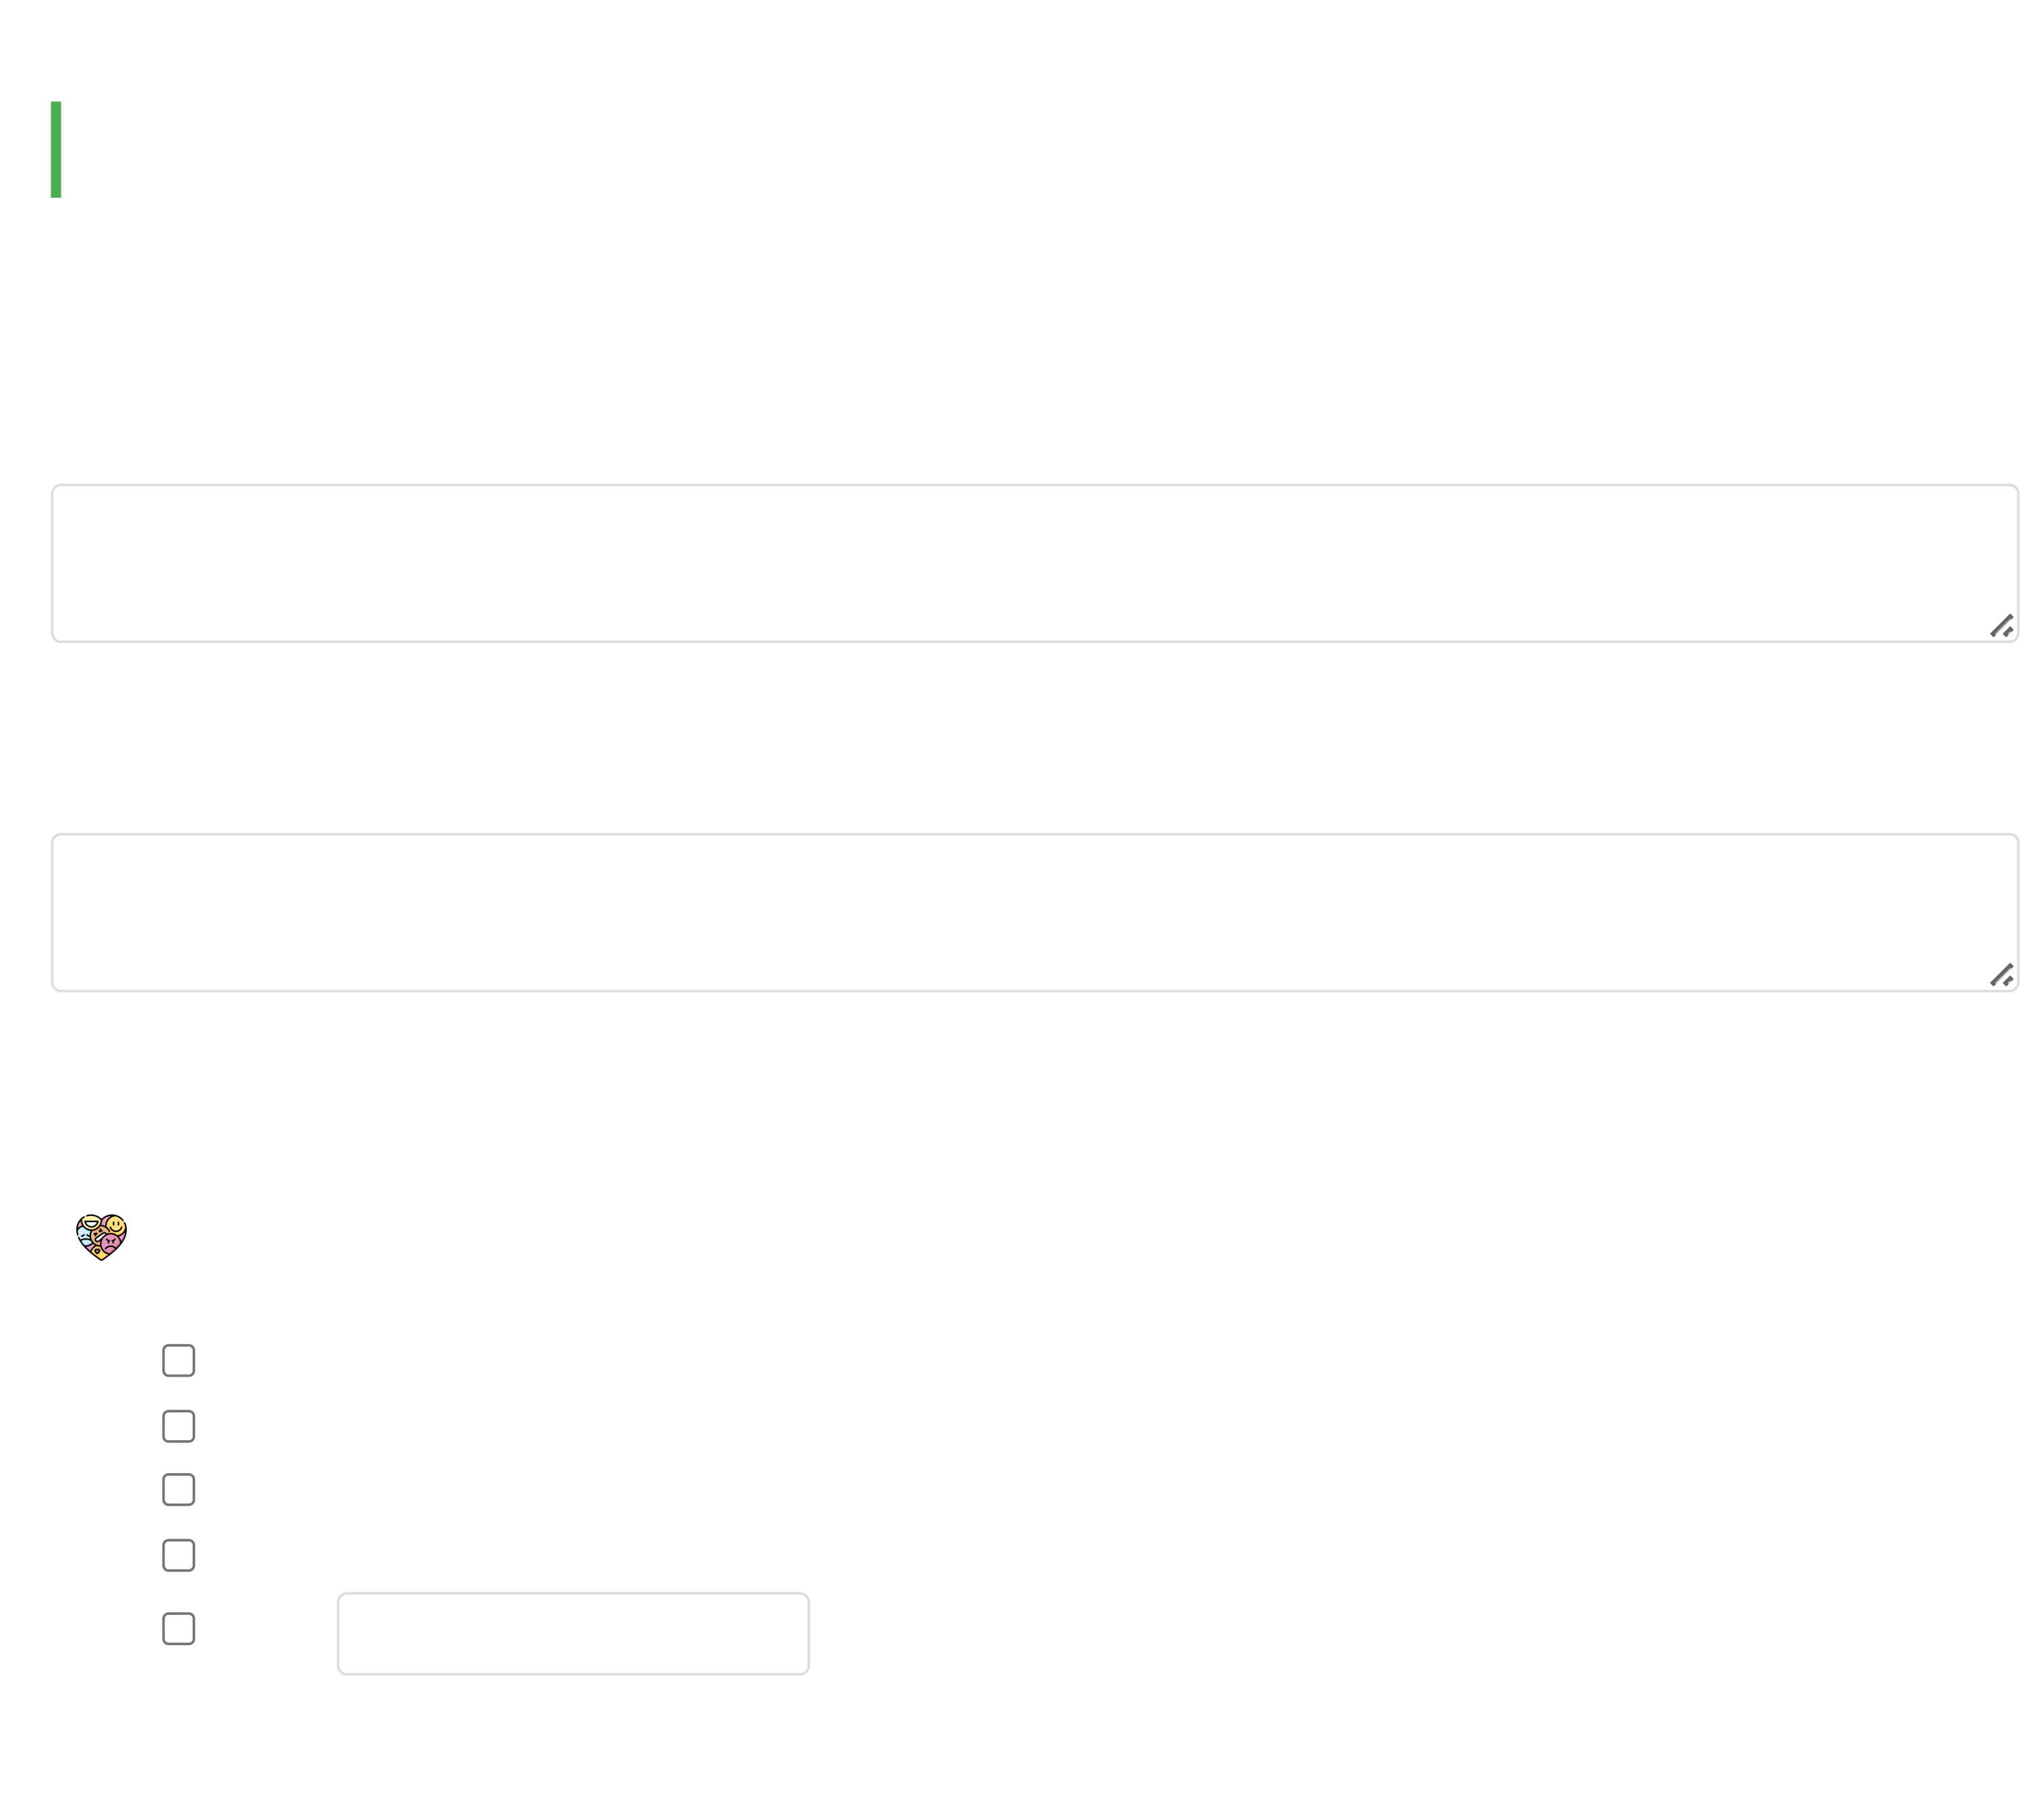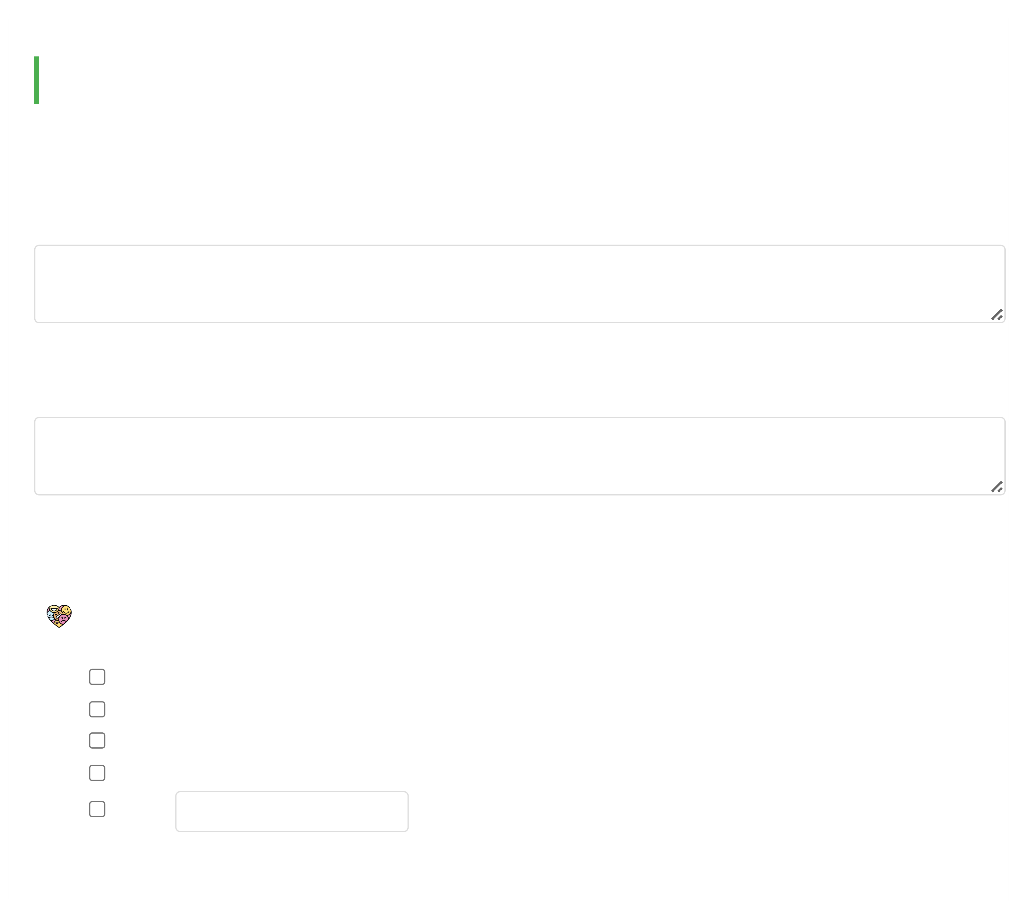

05/08/2025, 18:16 Hope for Recovery | Holistic Health Workbook

**Week 4: Emotional Health**

Today we explore emotional health - how to understand and manage our emotions for a happier life.

**1. How would you define emotional health?**

Group discussion notes...

**2. How might good emotional health help someone in addiction recovery?**

Group discussion notes...

**3. Ways to increase emotional health:**

**Emotional Health Toolkit:**

Identify and name your emotions daily

Practice deep breathing when stressed

Journal about your feelings

Talk to trusted friends or counselors

Other: Specify

***Memory Verse (Romans 12:2):***

file:///C:/Users/User1/Desktop/hope-for-recovery/workbooks/Holistic Health.html 7/20

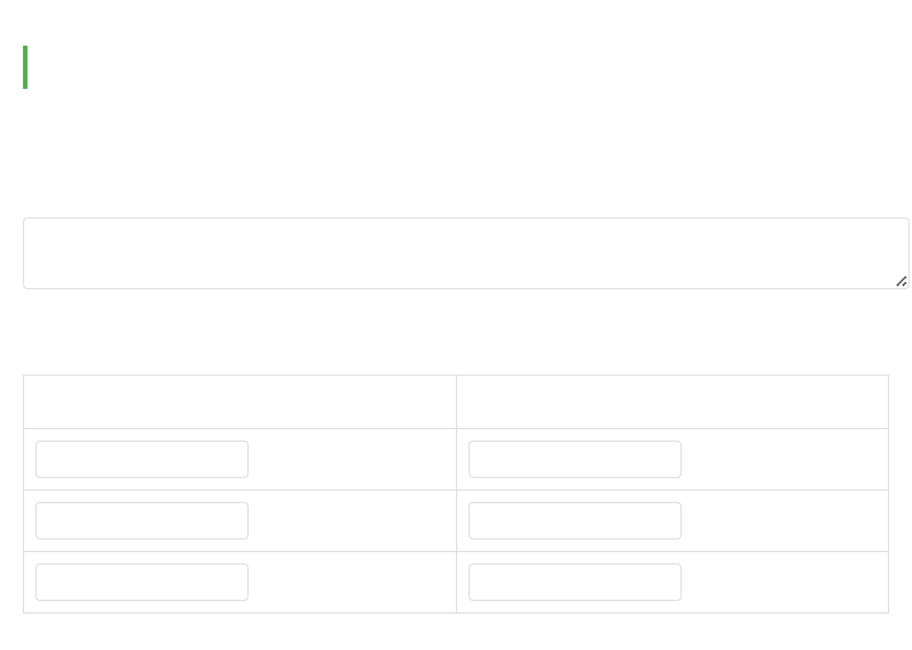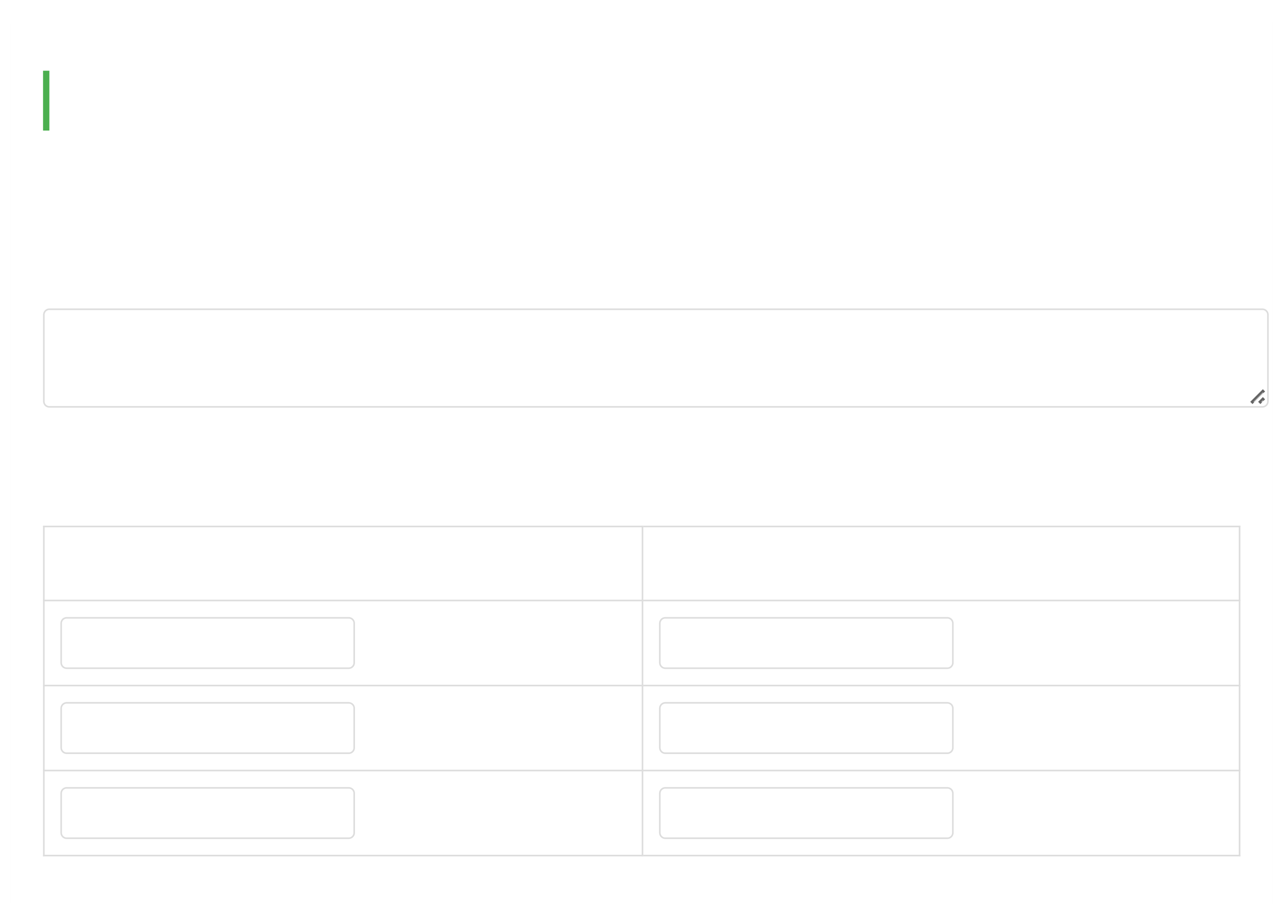

05/08/2025, 18:16 Hope for Recovery | Holistic Health Workbook

*"Do not conform to the pattern of this world, but be transformed by the renewing of your mind."*

*Emotional health begins with how we think and perceive our experiences.*

**Week 5: Personal Reflection**

Continuing our look at emotional health, we'll reflect on our emotional state and its causes.

**1. What are emotions and why do we have them?**

Your thoughts...

**2. List negative and positive emotions:**

**Negative Emotions Positive Emotions**

e.g., anger e.g., joy

file:///C:/Users/User1/Desktop/hope-for-recovery/workbooks/Holistic Health.html 8/20

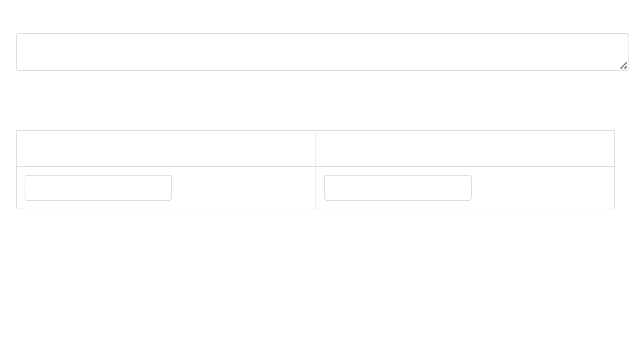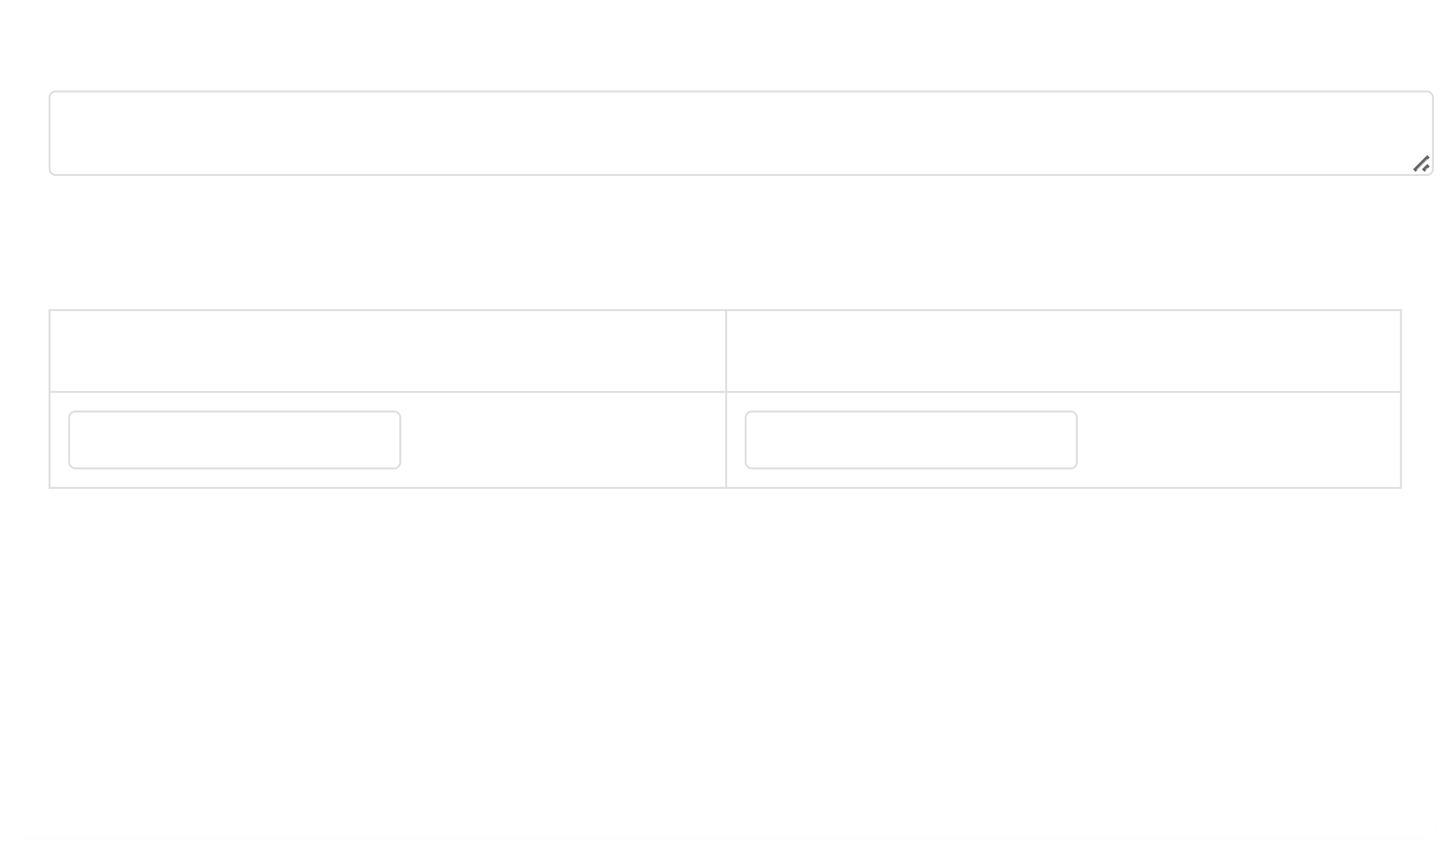

05/08/2025, 18:16 Hope for Recovery | Holistic Health Workbook

Which list would you rather live from and why?

Your response...

**3. Your emotional state this week:**

**Emotional State Why?**

Negative/Positive Reasons

***Memory Verse (Galatians 5:16):***

*"Walk by the Spirit, and you will not gratify the desires of the flesh."*

*Our spiritual walk directly impacts our emotional health.*

**Week 6: Living in the Moment**

Today we begin exploring mental health - starting with the principle of living in the present.

***Principle (Matthew 6:34):***

file:///C:/Users/User1/Desktop/hope-for-recovery/workbooks/Holistic Health.html 9/20

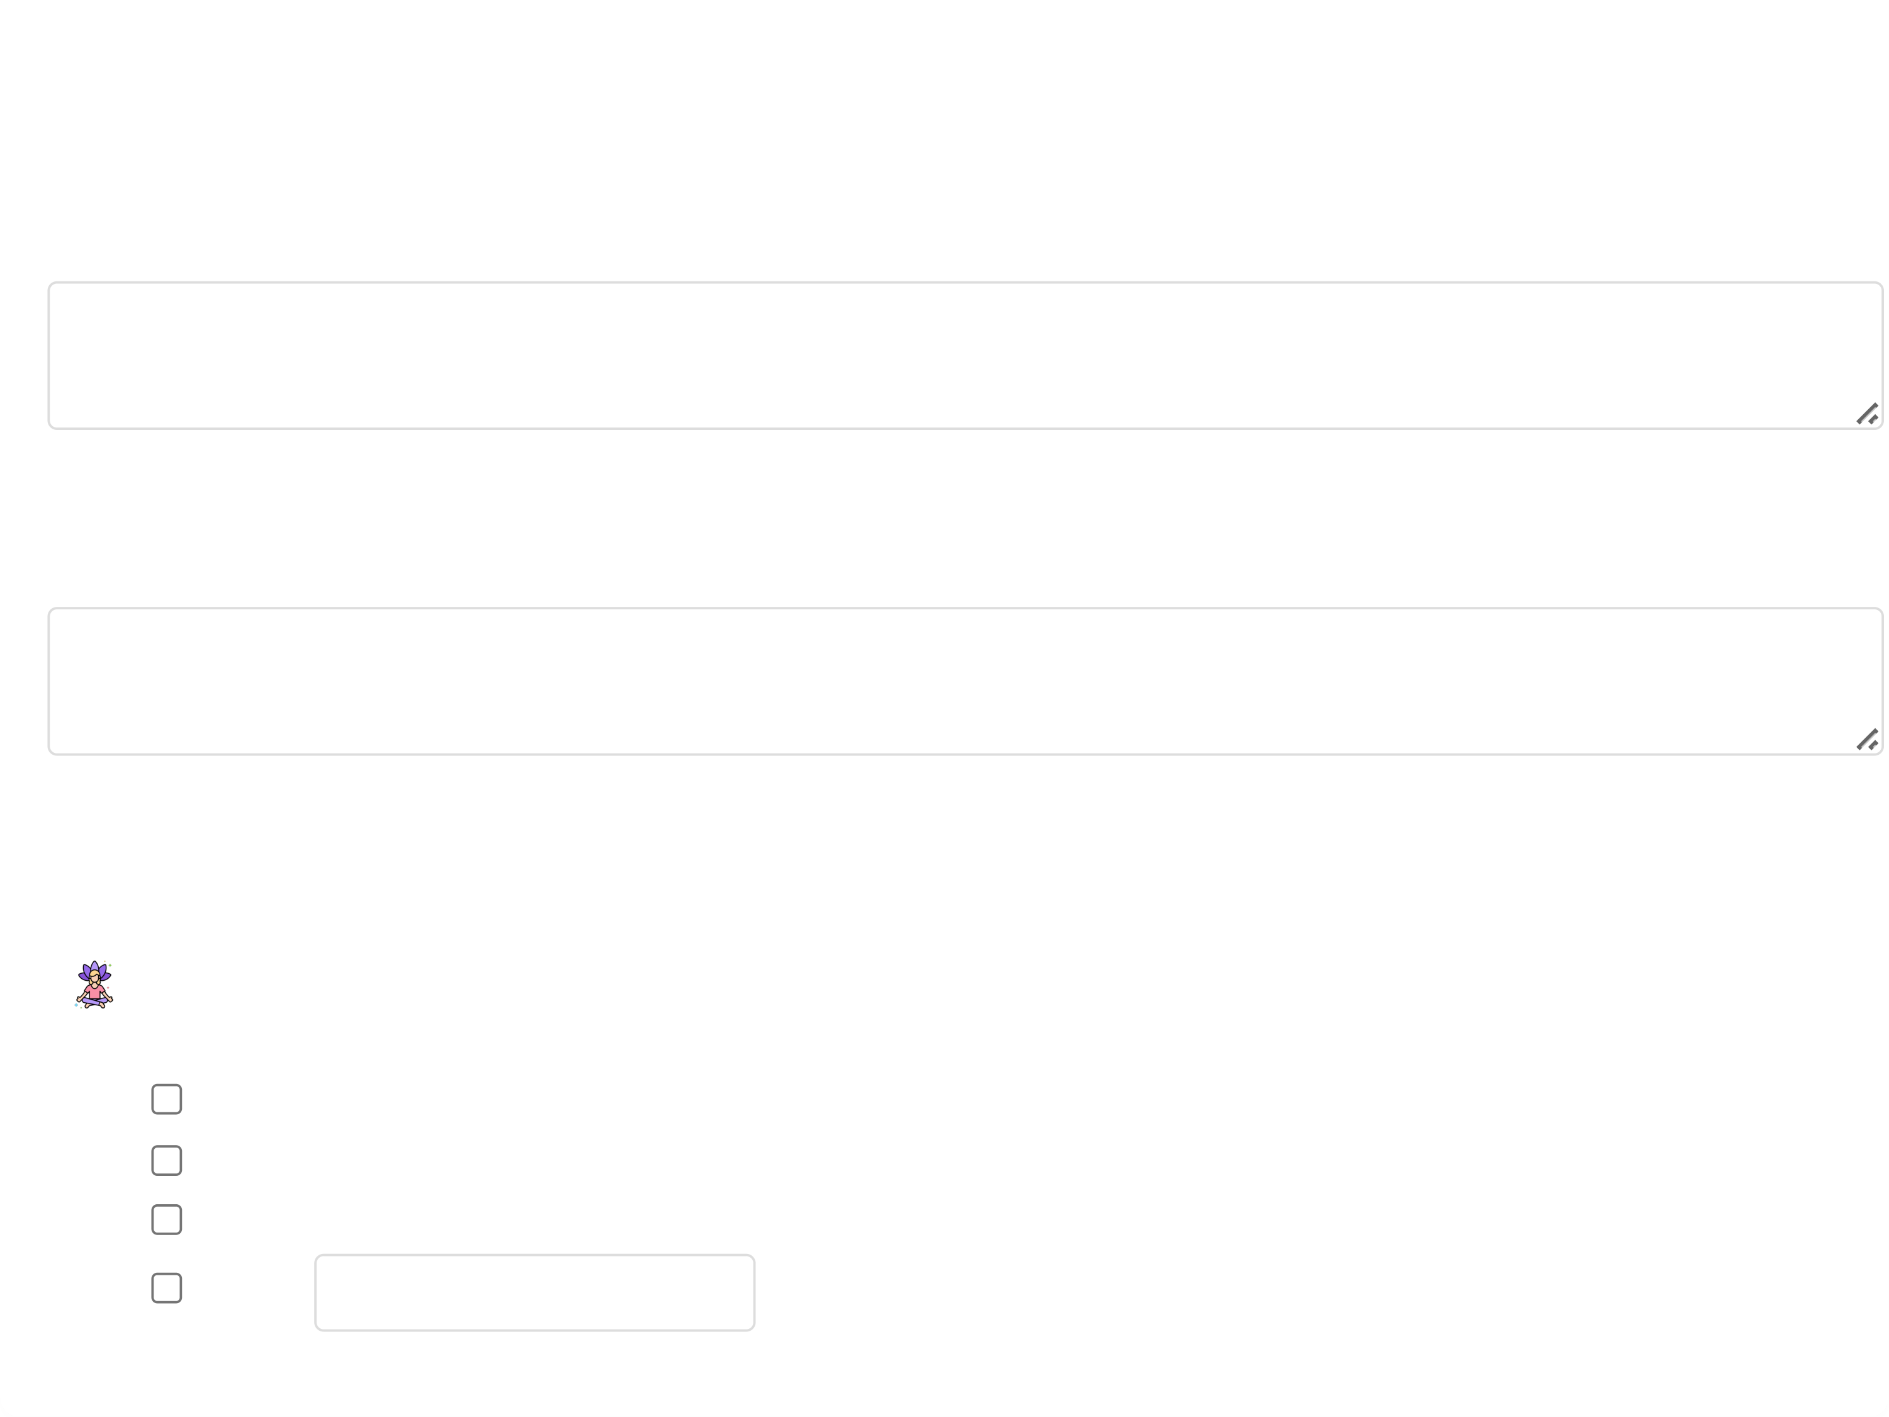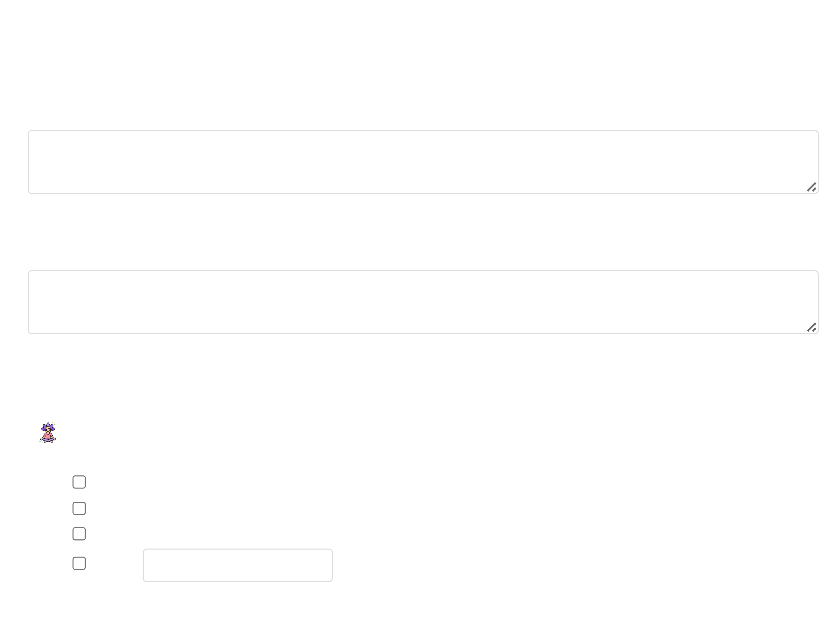

05/08/2025, 18:16 Hope for Recovery | Holistic Health Workbook

*"Therefore do not worry about tomorrow, for tomorrow will worry about itself."*

**1. What might be advantages of worrying?**

Group discussion notes...

**2. What are disadvantages of worrying?**

Group discussion notes...

**3. How can we apply this "present moment" principle daily?**

**Mindfulness Practices:**

Pause and breathe when anxious

Focus on one task at a time

Notice sensory details (sights, sounds)

Other: Specify

**Week 7: Gratitude is the Best Attitude**

file:///C:/Users/User1/Desktop/hope-for-recovery/workbooks/Holistic Health.html 10/20



05/08/2025, 18:16 Hope for Recovery | Holistic Health Workbook

Continuing mental health principles, we explore how gratitude improves our mindset.

***Principle (1 Thessalonians 5:18):***

*"Give thanks in all circumstances, for this is God's will for you in Christ Jesus."*

**1. List three things you're thankful for:**

1.

2.

3.

**2. Benefits of a grateful attitude:**

Group discussion notes...

**3. How to practice gratitude daily:**

**Gratitude Practices:**

Keep a gratitude journal

Share thanks during meals

Thank someone daily

file:///C:/Users/User1/Desktop/hope-for-recovery/workbooks/Holistic Health.html 11/20

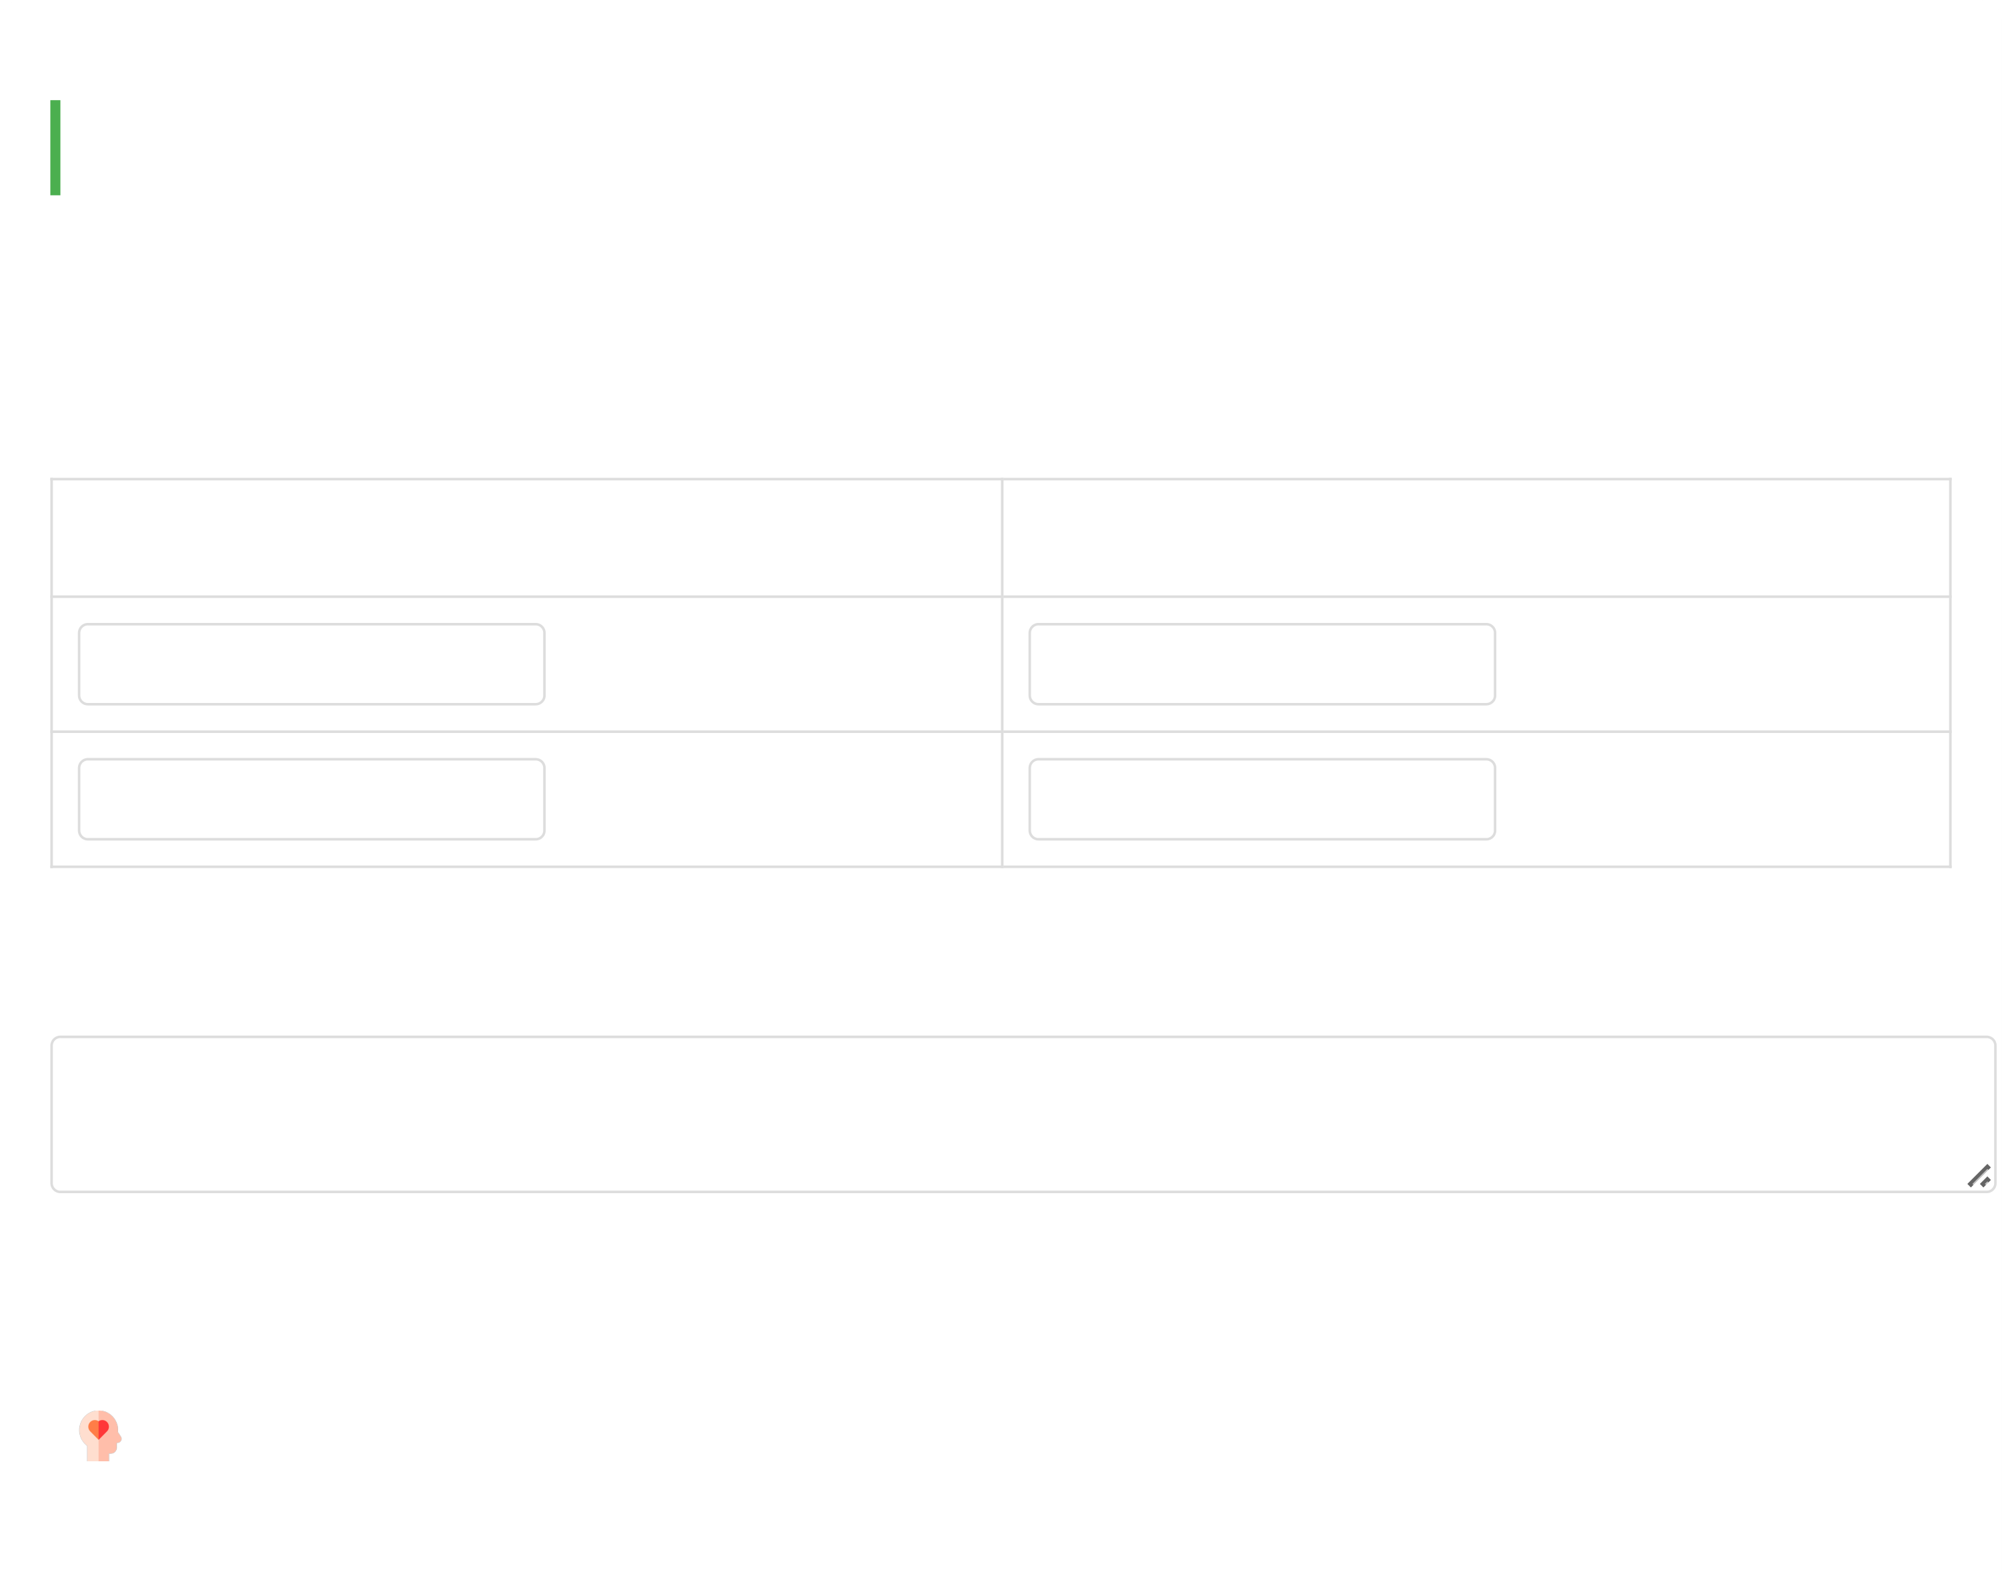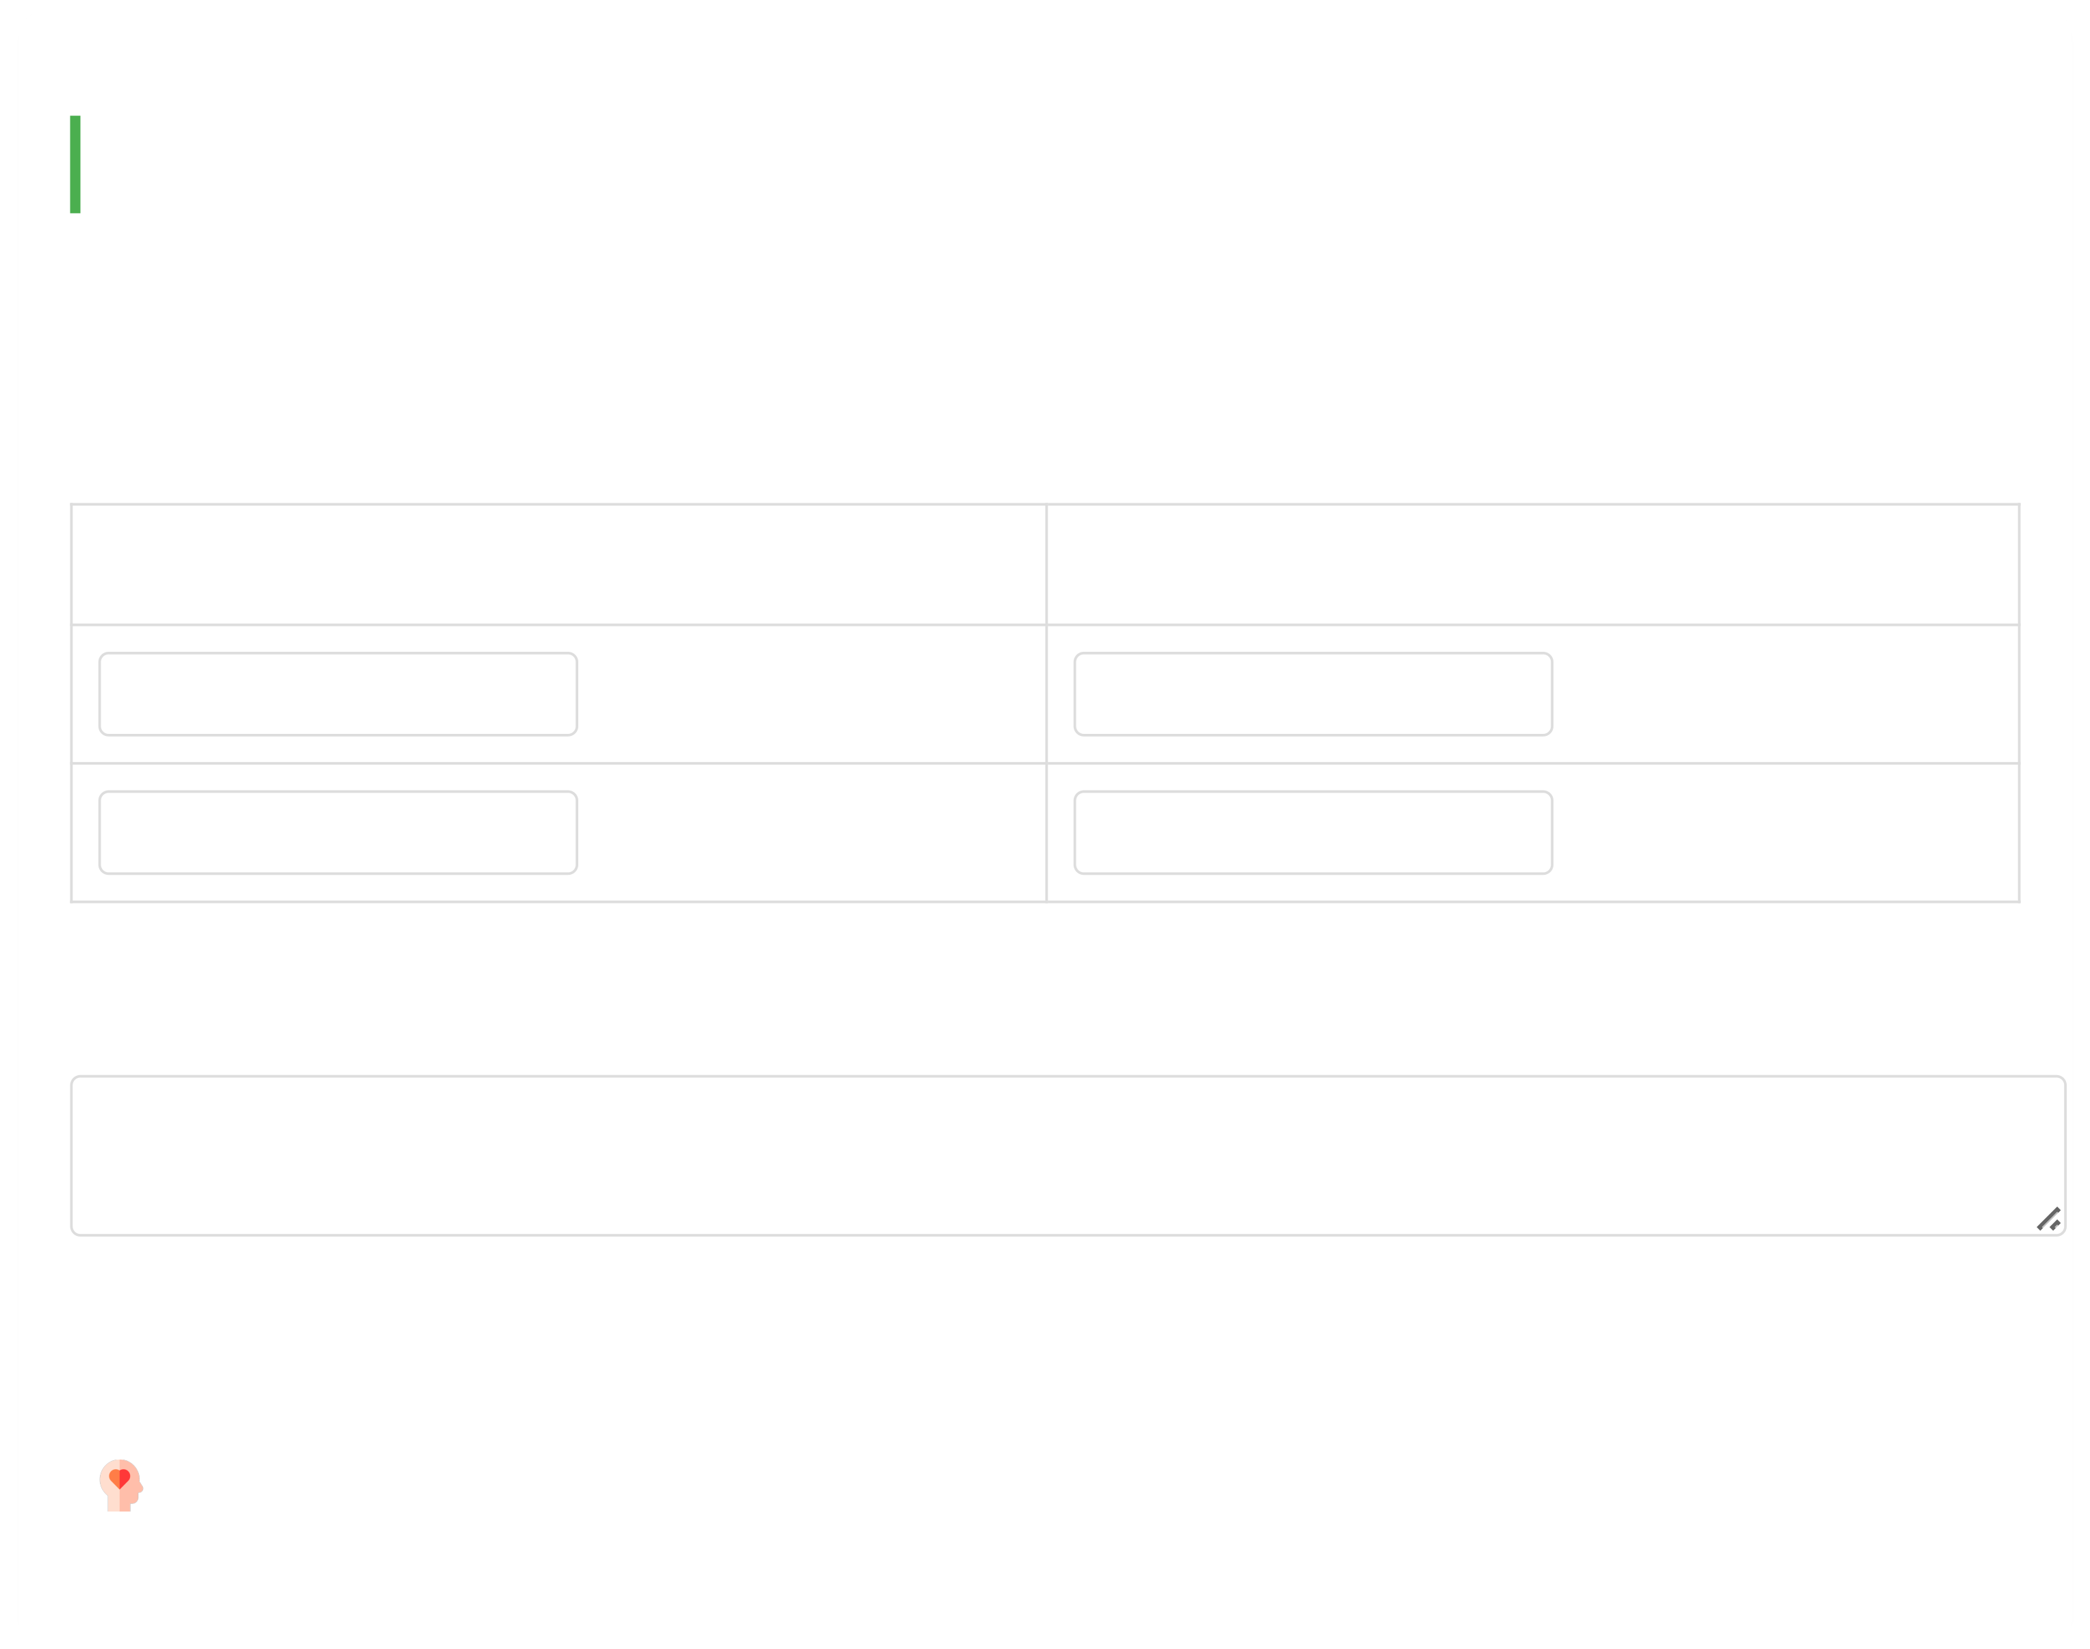

05/08/2025, 18:16 Hope for Recovery | Holistic Health Workbook

Other: Specify

**Week 8: Mental Health**

Today we explore mental health - what it is, how it differs from physical health, and ways to improve it.

**1. Words associated with mental vs. physical health:**

**Mental Health Physical Health**

e.g., thoughts e.g., exercise

**2. How would you define mental health?**

Group discussion notes...

**3. Ways to improve mental health:**

**Mental Wellness Strategies:**

file:///C:/Users/User1/Desktop/hope-for-recovery/workbooks/Holistic Health.html 12/20

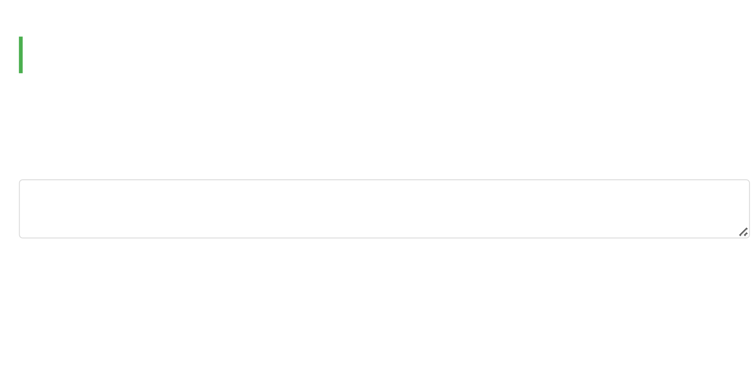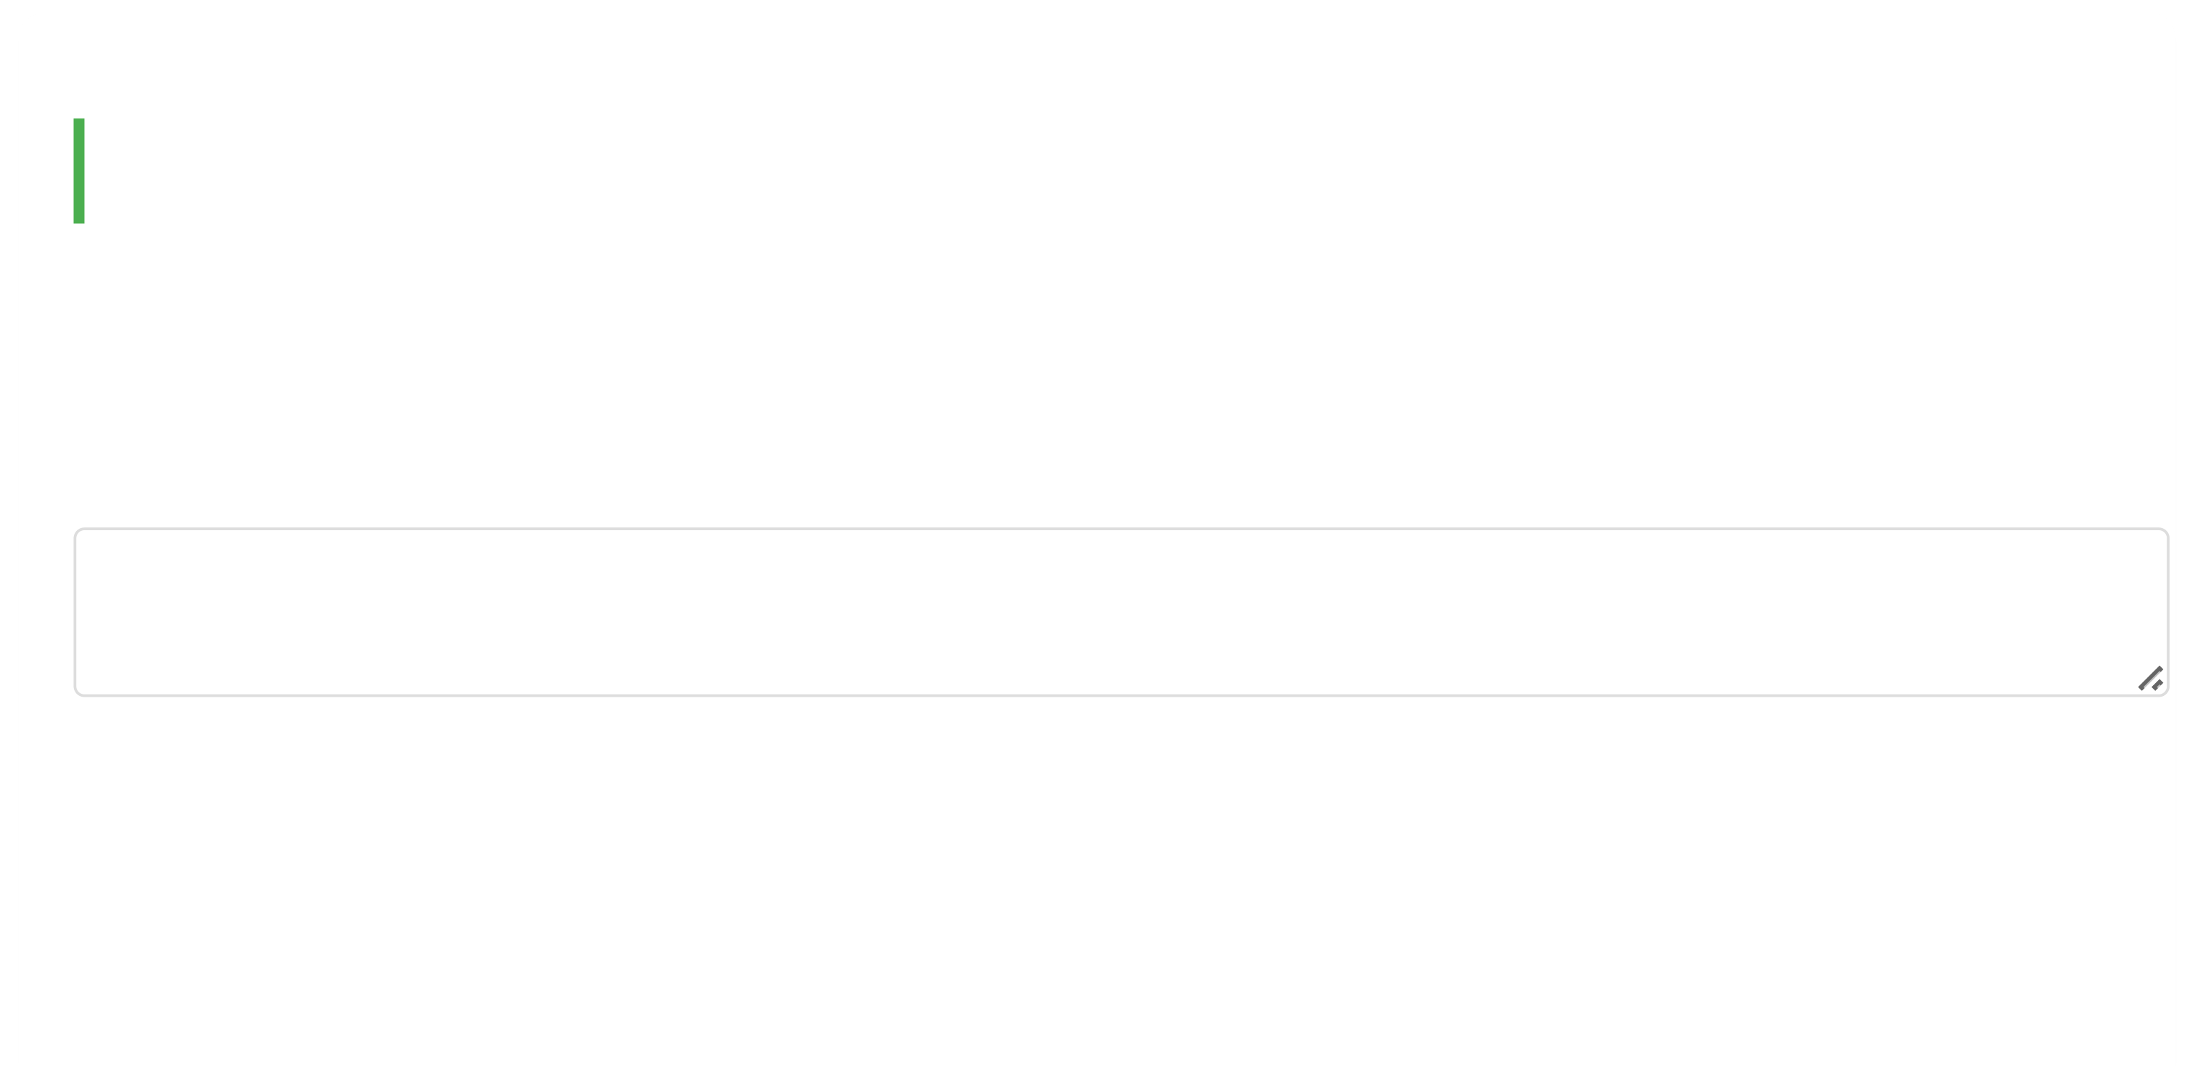

05/08/2025, 18:16 Hope for Recovery | Holistic Health Workbook

Challenge negative thoughts

Engage in stimulating activities

Practice relaxation techniques

Other: Specify

***Memory Verse (Psalm 42:5):***

*"Why, my soul, are you downcast? Put your hope in God."*

*When our minds are troubled, we can turn to God for peace.*

**Week 9: Spiritual Health**

Today we begin exploring spiritual health - what it is, its benefits, and how to nurture it.

**1. How would you define spiritual health?**

Group discussion notes...

**2. How might spiritual health help someone in addiction?**

file:///C:/Users/User1/Desktop/hope-for-recovery/workbooks/Holistic Health.html 13/20

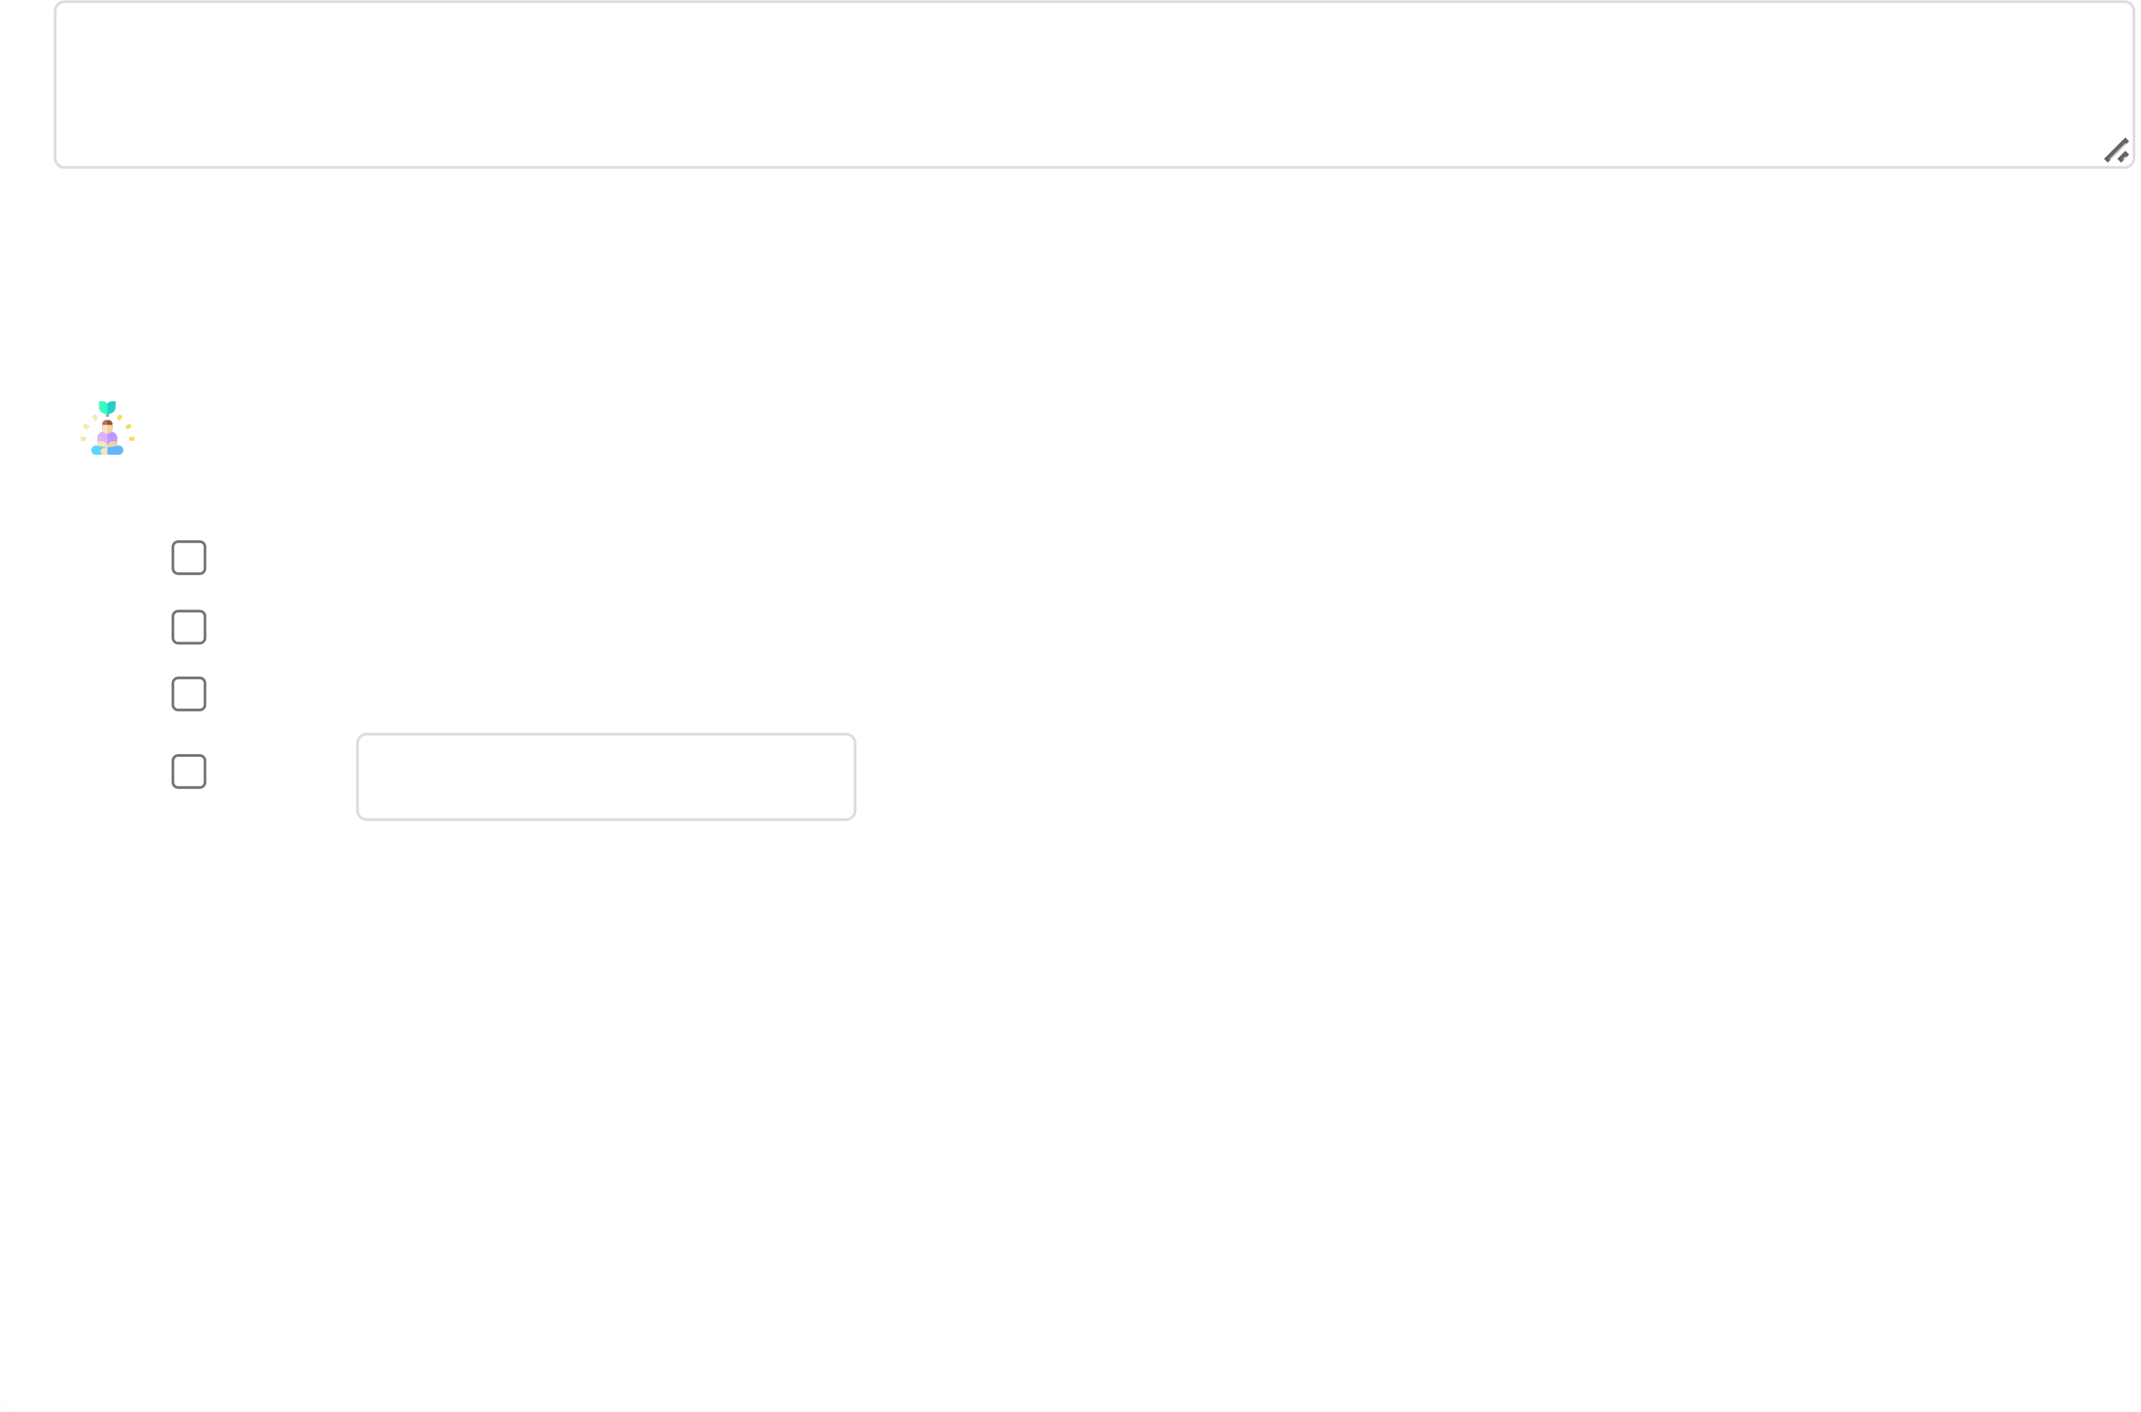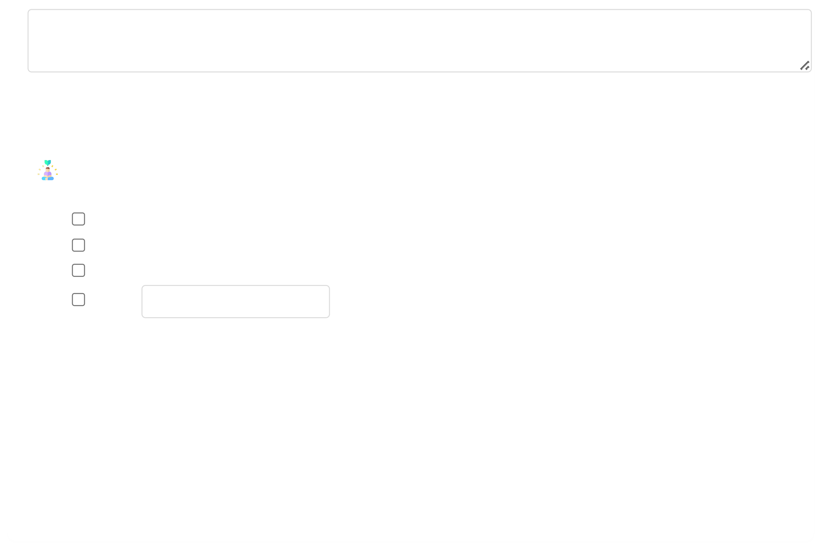

05/08/2025, 18:16 Hope for Recovery | Holistic Health Workbook

Group discussion notes...

**3. Ways to increase spiritual health:**

**Spiritual Growth Practices:**

Daily prayer/meditation

Scripture reading

Worship participation

Other: Specify

***Memory Verse (Ephesians 3:16):***

*"I pray that out of his glorious riches he may strengthen you with power through his Spirit in your inner*

*being."*

*Spiritual health comes from God's strength within us.*

**Week 10: Awareness vs. Awakening**

Continuing spiritual health, we explore whether spirituality requires awareness or awakening.

file:///C:/Users/User1/Desktop/hope-for-recovery/workbooks/Holistic Health.html 14/20

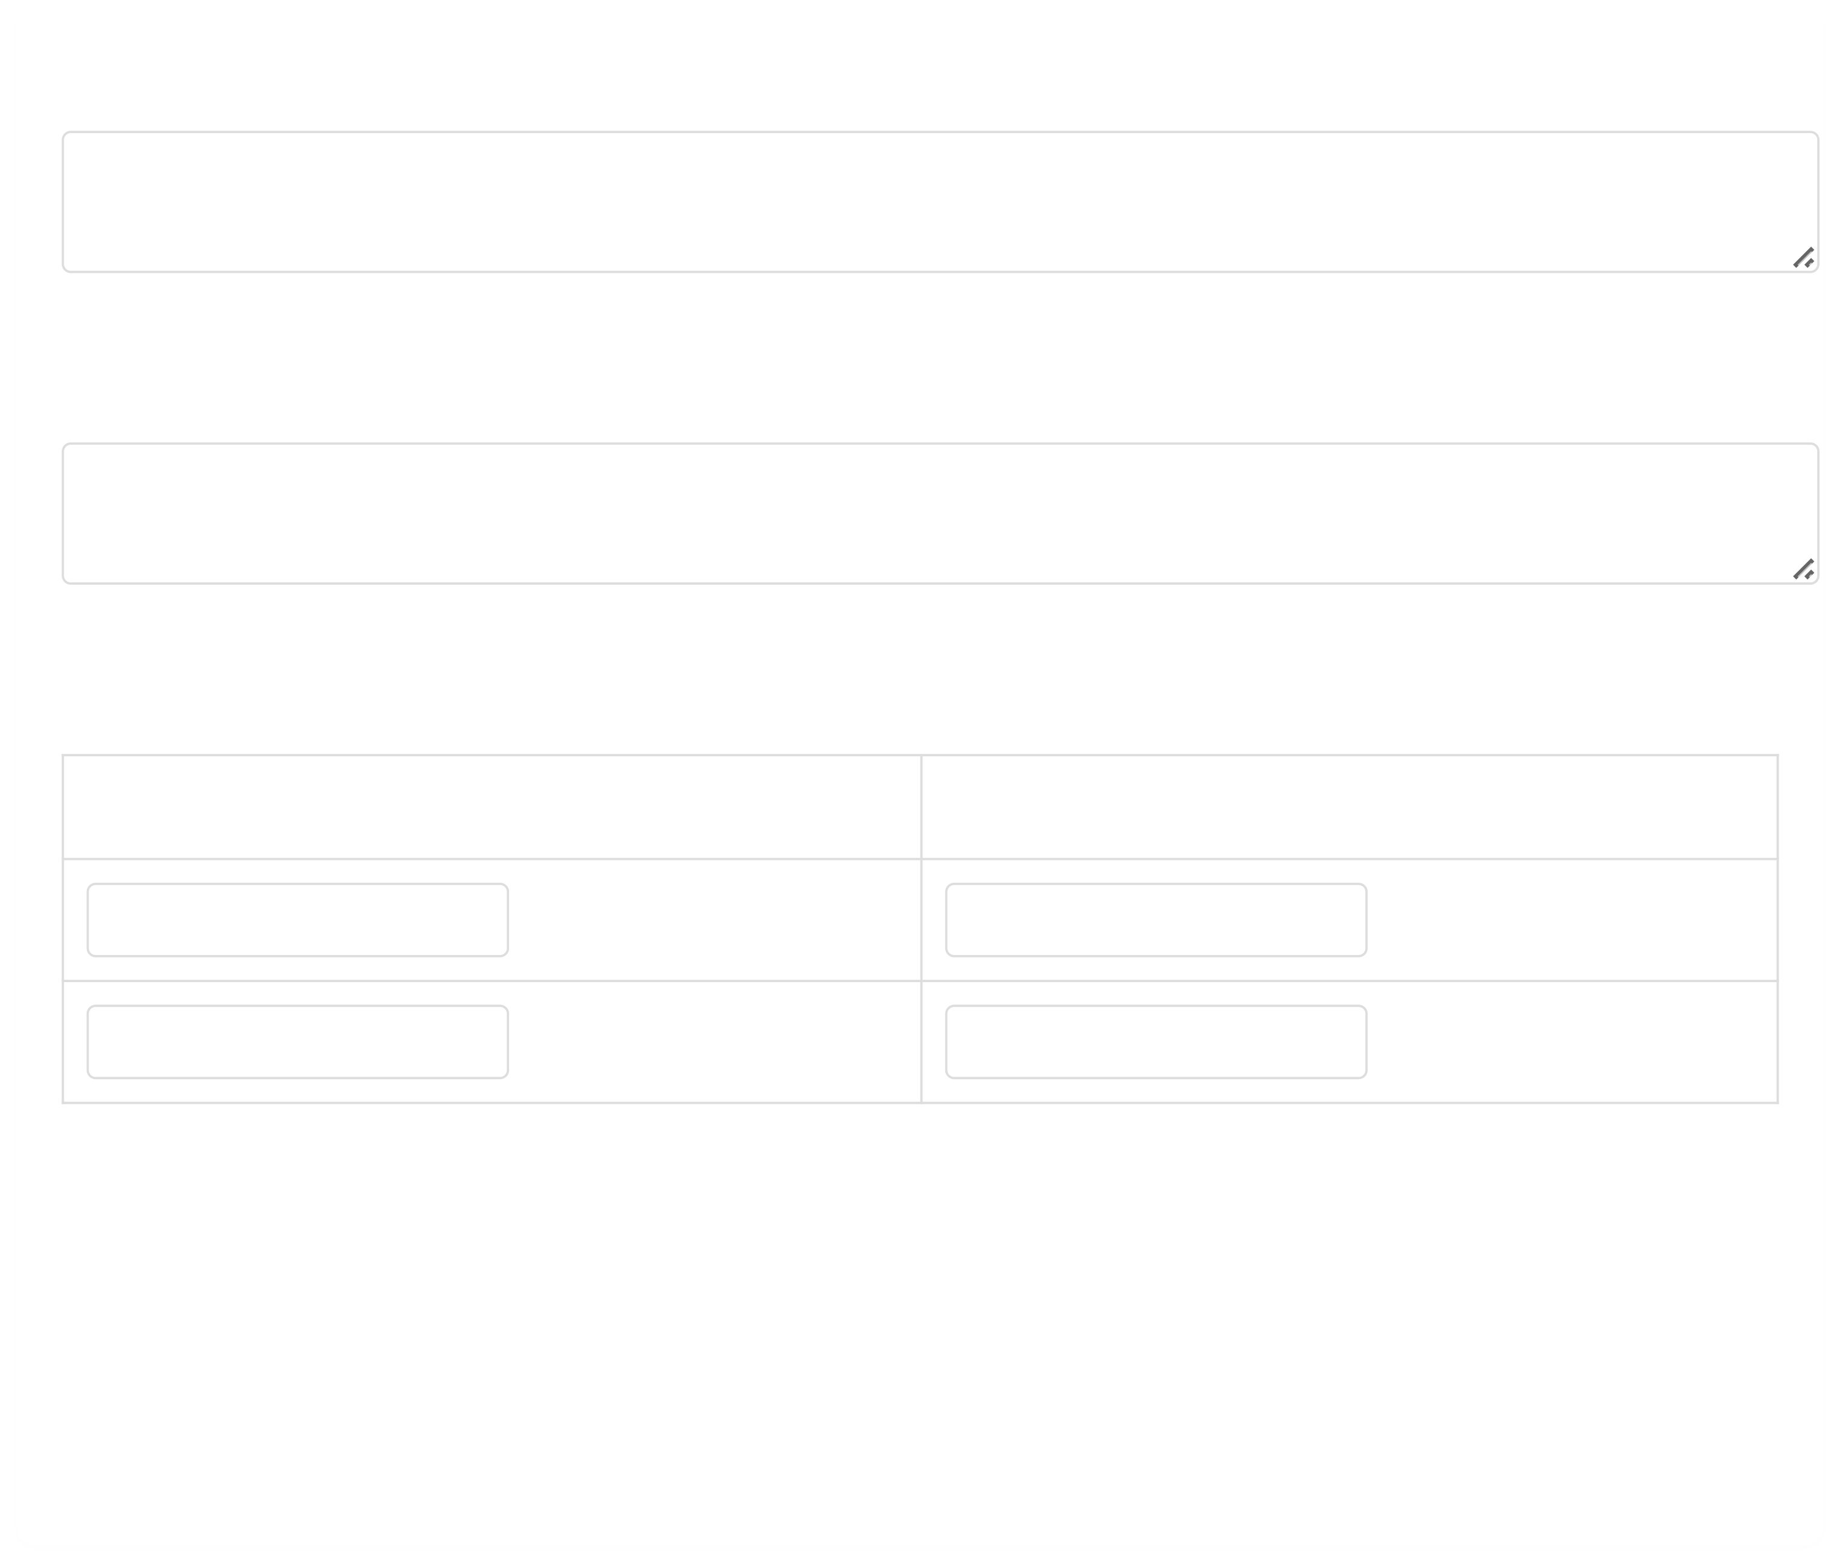

05/08/2025, 18:16 Hope for Recovery | Holistic Health Workbook

**1. Is spirituality about awareness or awakening?**

Group discussion notes...

**2. How might spirituality be awakened in someone?**

Group discussion notes...

**3. What hinders spiritual awakening? How to overcome?**

**Hindrances Solutions**

e.g., doubt e.g., prayer

***Memory Verse (John 10:10):***

*"I have come that they may have life, and have it to the full."*

*Jesus offers us complete spiritual awakening and abundant life.*

file:///C:/Users/User1/Desktop/hope-for-recovery/workbooks/Holistic Health.html

15/20

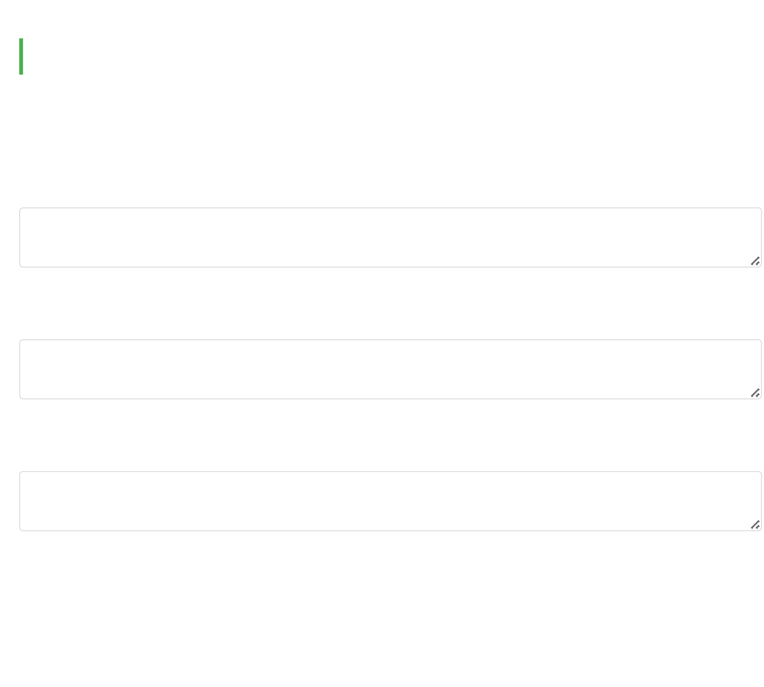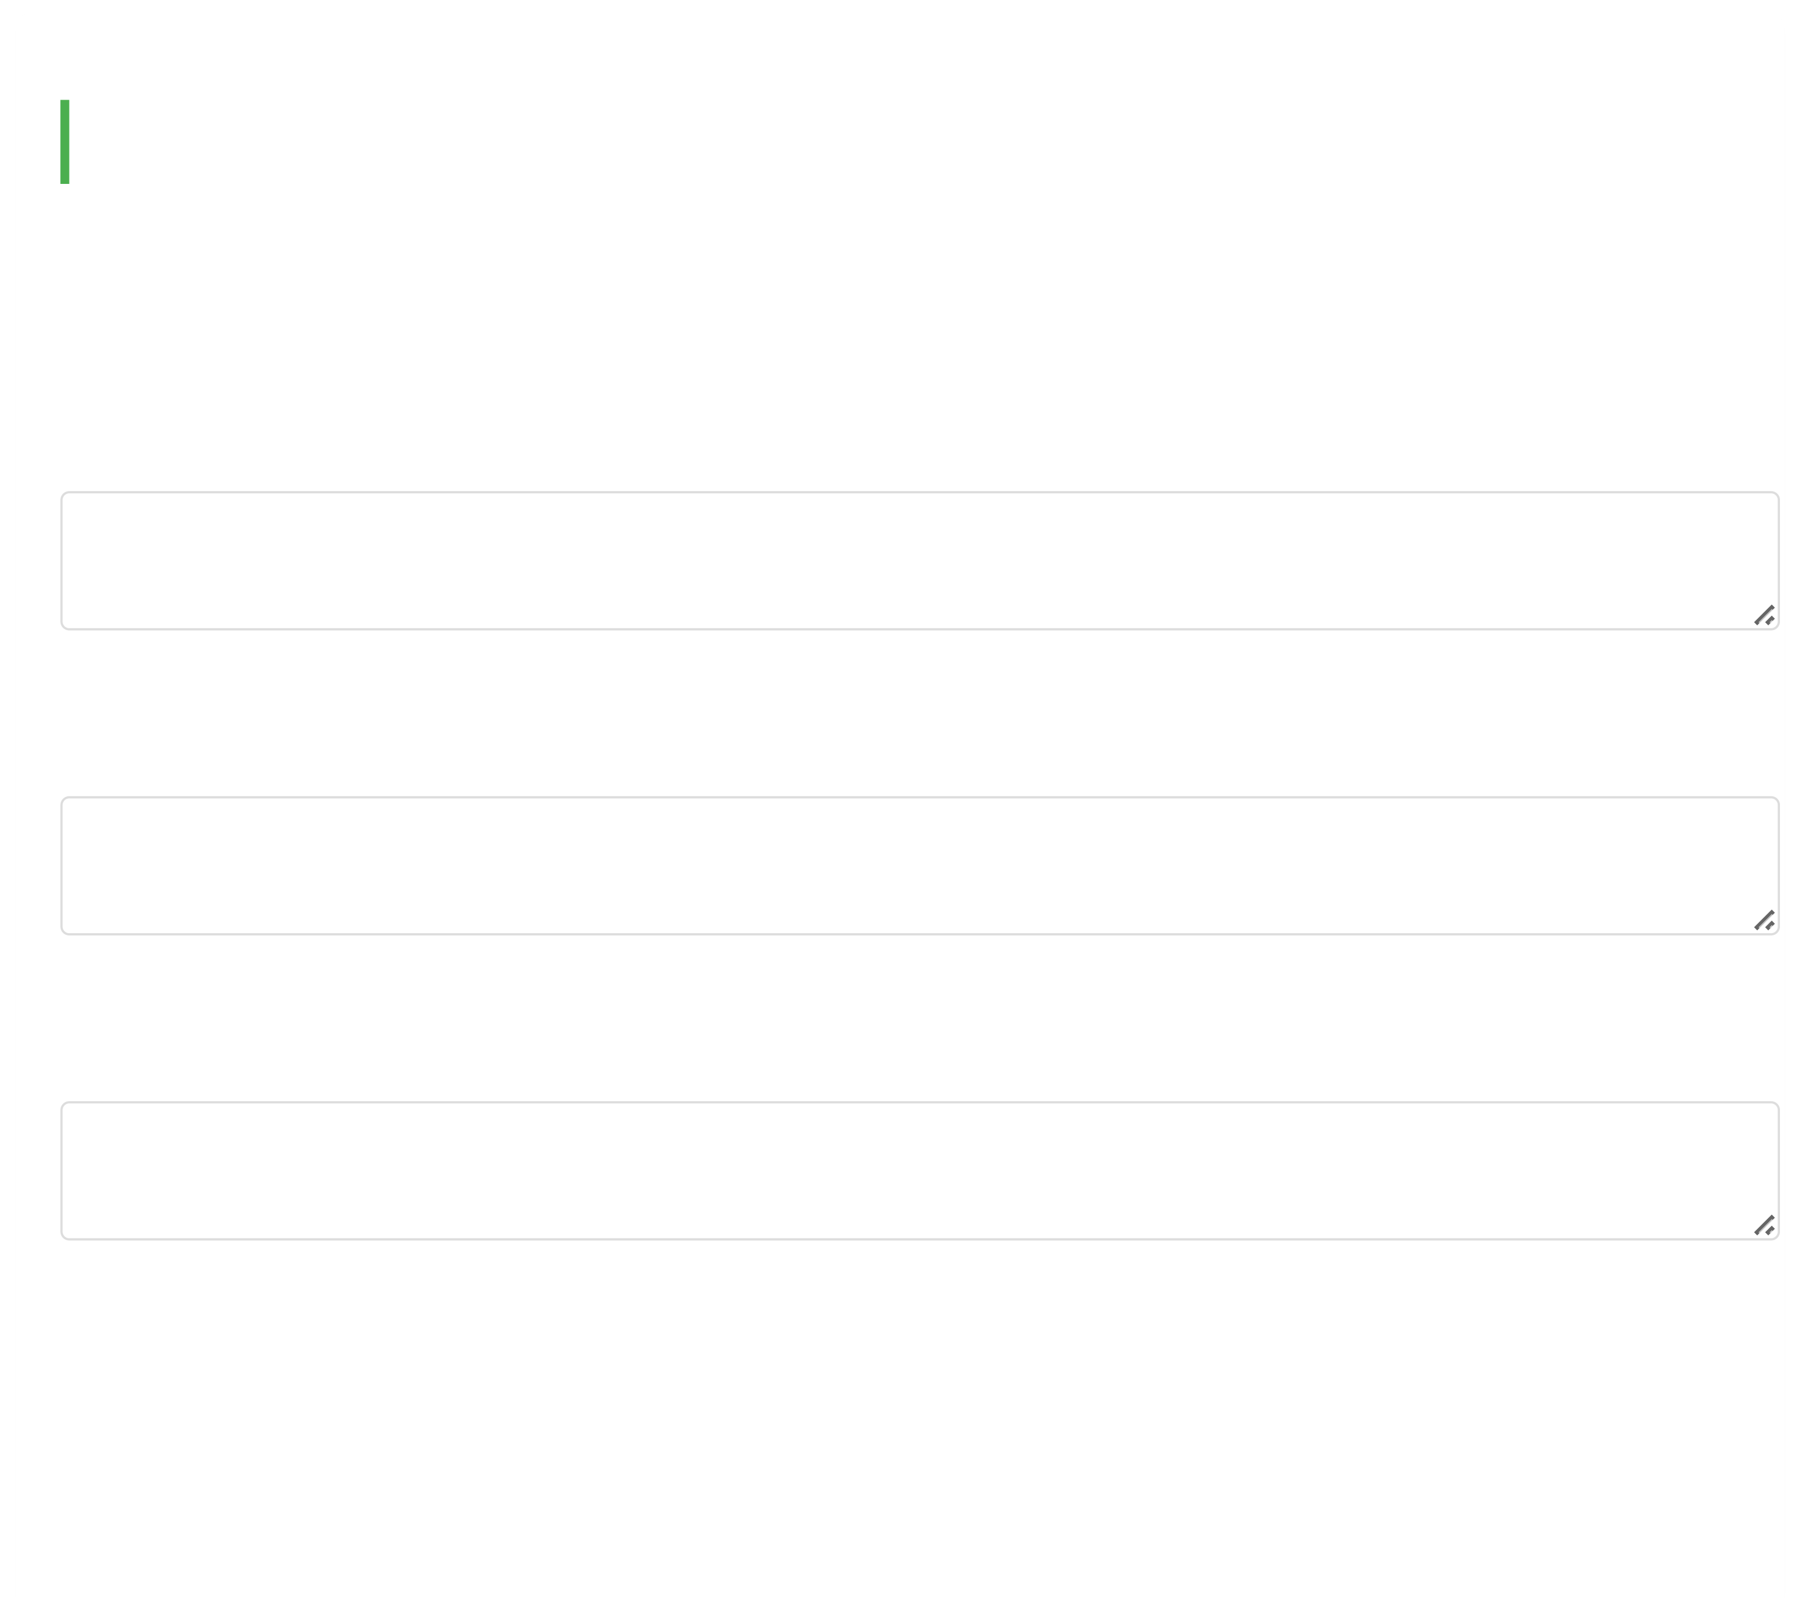

05/08/2025, 18:16 Hope for Recovery | Holistic Health Workbook

**Week 11: Case Study - John's Story**

*John has been a Christian for 18 years but struggles with guilt and relapses into heroin use. He feels*

*disconnected from God and unworthy of love.*

**1. How would you describe John's spiritual health?**

Group discussion notes...

**2. How might you help John improve his spiritual health?**

Group discussion notes...

**3. What positive impacts might improved spiritual health have on John's life?**

Group discussion notes...

***Memory Verse (Colossians 1:14):***

*"In whom we have redemption, the forgiveness of sins."*

file:///C:/Users/User1/Desktop/hope-for-recovery/workbooks/Holistic Health.html 16/20



05/08/2025, 18:16 Hope for Recovery | Holistic Health Workbook

*John needs to embrace God's complete forgiveness.*

**Week 12: Final Assessment**

Re-evaluate your holistic health components and compare to Week 1:

**Health Area Importance (Rank 1-4) Current Score (1-10)**

Physical

Mental

Spiritual

Emotional

**Reflection:**

How has your understanding of holistic health changed during this course?

Your reflections...

file:///C:/Users/User1/Desktop/hope-for-recovery/workbooks/Holistic Health.html 17/20

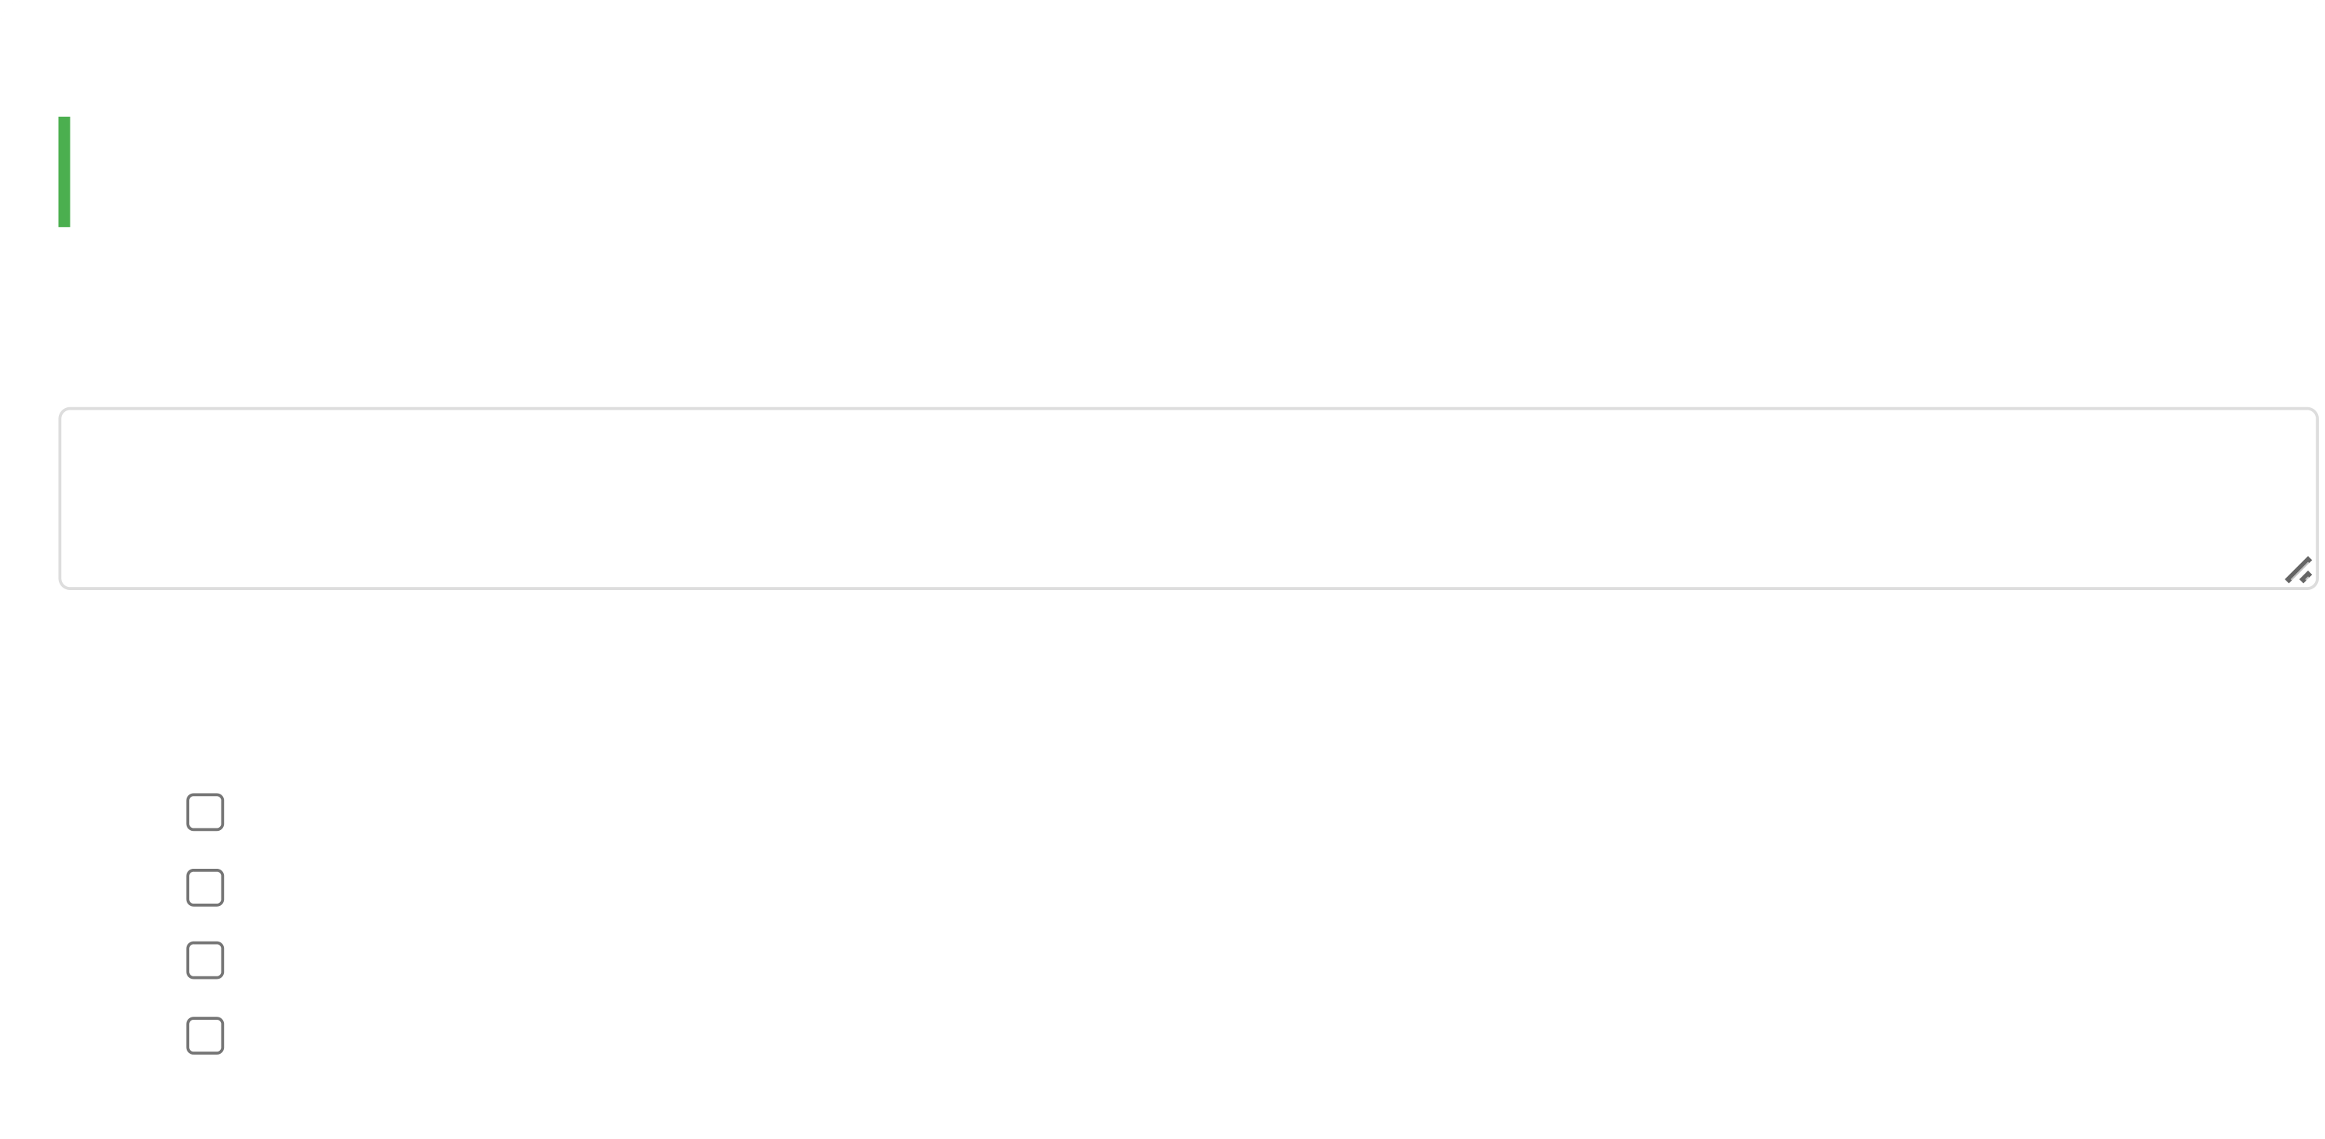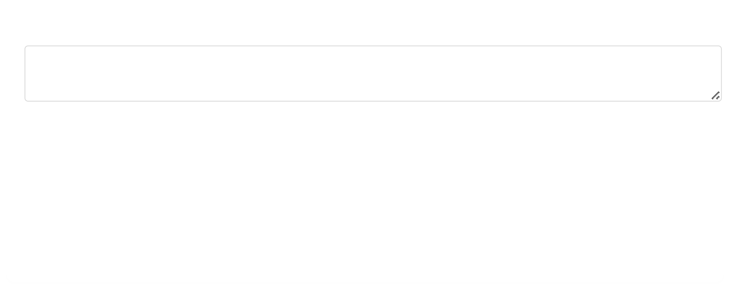

05/08/2025, 18:16 Hope for Recovery | Holistic Health Workbook

What specific changes have you made in each area?

Your progress...

***Memory Verse (Ephesians 5:18):***

*"Be filled with the Spirit."*

*As we conclude, may you continue to be filled with God's Spirit in all areas of life.*

**Course Feedback**

**1. Which week was most impactful for you? Why?**

**2. What specific changes have you noticed in these areas?**

Physical health

Emotional well-being

Mental clarity

Spiritual growth

file:///C:/Users/User1/Desktop/hope-for-recovery/workbooks/Holistic Health.html

18/20

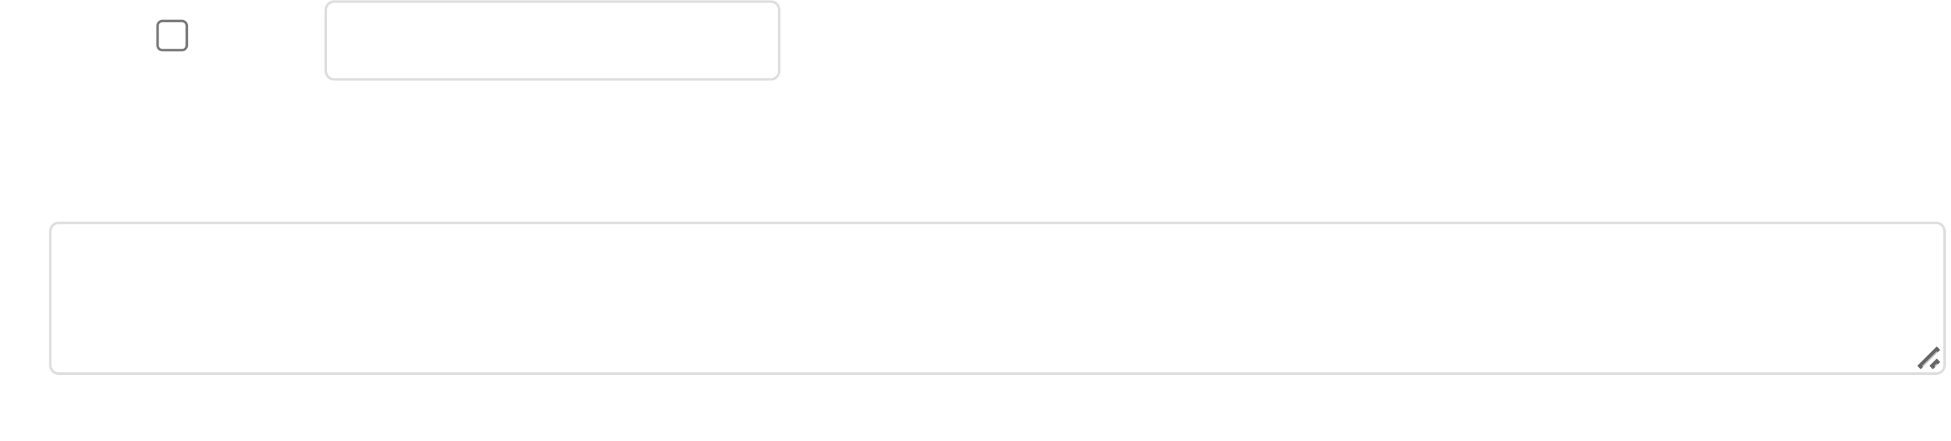

05/08/2025, 18:16 Hope for Recovery | Holistic Health Workbook

Other:

**3. How could we improve this course?**

**Additional Resources**

**Recommended Reading:**

*The Whole Person Recovery* by Dr. Sarah Johnson

*Mind-Body-Spirit Connection* by Rev. Michael Brown

*Addiction and Grace* by Gerald May

**Support Tools:**

Meditation apps: "Calm", "Headspace", or "Abide" (Christian meditation)

Fitness/nutrition: "MyFitnessPal" or "Cronometer"

Bible study: "YouVersion Bible App"

**Local Support:**

Contact Hope for Recovery for information about ongoing support groups and counseling services.

file:///C:/Users/User1/Desktop/hope-for-recovery/workbooks/Holistic Health.html

19/20

05/08/2025, 18:16 Hope for Recovery | Holistic Health Workbook

Copyright © Hope for Recovery | September 2023 | Craig Halkett

file:///C:/Users/User1/Desktop/hope-for-recovery/workbooks/Holistic Health.html

20/20